By - Mihir Hattangdi

**decoding football: a data driven approach for uncovering football insights**

Contents

1. Project Overview 2

2. Overview of the Data Set 2

Data Merging for Tableau: 5

Data Import for MySQL Server: 6

4. Business Objectives 7

5. Analysis 8

a. Performance Analysis 8

b. PLAYER PROFILE AND MARKET TRENDS 22

c. TEAM COMPARISON 30

d. ATTENDANCE AND STADIUM ANALYSIS 36

e. REFEREE ANALYSIS 44

f. SUBSTITUTION ANALYSIS Using Tableau Charts 46

g. EVENT ANALYSIS 48

h. COMPETITION ANALYSIS 52

i. PLAYER ATTRIBUTES AND DEMOGRAPHICS ANALYSIS 53

j. CONTRACT MANAGEMENT 61

6. Exporting Files for PowerPoint Presentation 62

7. INTERPRETATIONS AT A GLANCE: 63

**Aggregated Summary of All Focus Areas** 65

**Comprehensive Analysis of Machine Learning Models and Hypothesis Testing** 66

1. Project Overview
   1. This is a Comprehensive Data Analytics Project Documentation on Soccer Games, Teams and Key players from the United States Men’s National Football.
   2. My aim here is to document the processes, steps and methods I have followed to get relevant data and generate charts for the relevant data.
   3. In this Documentation I go through understanding the dataset, processing the data, converting the cleaned data to relevant formats to infer and find answers to relevant questions to the business objectives.
   4. The Tools used in this Project are:
      1. Python – NumPy, Pandas, matplotlib, Seaborn, Scikit-Learn Libraries (machine learning & deep analysis)
      2. MySQL Workbench (access data from databases)
      3. Rows Ai (online tool for quick analysis)
      4. ChatGPT (for quick codes and summarizations)
      5. MS Excel (for quick calculations and presentation reports)
      6. Tableau (for building dashboards and visualizing complex relations)
   5. This Data analytical attempt is based on the data provided by NIIT
2. Overview of the Data Set

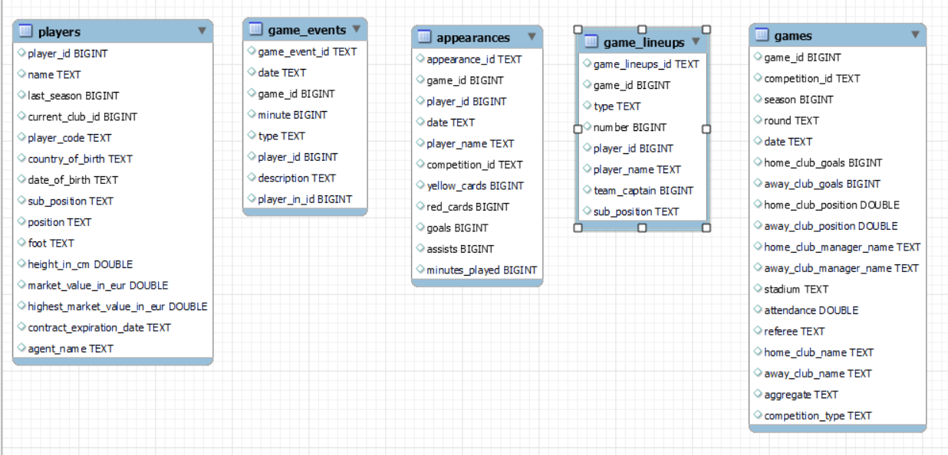

* 1. The Above Image depicts the Data Set given
  2. Details for each Data set:
     1. players and their in-game related statistics,
     2. the special game events like substitutions, goals, and fouls for each of the players based on each games played,
     3. some key player appearances in games like number of yellow/red cards, number of goals and number of assists made by players for each game played,
     4. player lineup details like whether team captain or not, whether a substitute or a starting lineup player,
     5. and games wise each detail for season, each competition id(leagues), the teams facing each other, goals scored by each team, the managers, stadium and referee details
  3. The

1. Data Cleaning and Merging
   1. Performing Data Cleaning Using Python
   2. Each Table is separately treated in Jupyter notebook

Following Changes have been made in each table

|  |  |  |  |
| --- | --- | --- | --- |
| TABLE | COLUMNS REMOVED | MISSING VALUES | OUTLIERS TREATED |
| Appearance_df | - | - | - |
| Players_df | - | Height – mean MarketVal, highest_market_value – median | - |
| Games_df | - | Attendance - median | - |
| Game_events_df | Player_assist_id | Player_in_id – 0 (no player referred) description – ‘Not Available’ | - |
| Games_lineups | - | - | - |
|  |  |  |  |
|  |  |  |  |

Each of these tables have been converted to a csv file further

Further, Numerical and Categorical columns have been also identified for each table

The Data cleaning has been performed using Python

|  |  |  |  |
| --- | --- | --- | --- |
| NUMERICAL | DICTIONARY | CATEGORICAL | DICTIONARY |
| 'game_id' | Unique game id | appearance_id | Unique id for this table |
| player_id | Unique player id | date | Game date |
| yellow_cards | No of Yellow cards | player_name | Player name |
| red_cards | No of Red cards | competition_id | Unique id for competition |
| goals | Goals |  |  |
| assists | assists |  |  |
| minutes_played | Total minutes played |  |  |

|  |  |  |  |
| --- | --- | --- | --- |
| NUMERICAL | DICTIONARY | CATEGORICAL | DICTIONARY |
| player_id | Unique player id | name | name |
| 'last_season' | Last season player participated | player_code | Unique player code |
| current_club_id | Unique club id | country_of_birth | Birth country |
| height_in_cm | height | date_of_birth | Birth date |
| market_value_in_eur | Current market value of player | sub_position | Exact position on field |
| highest_market_value_in_eur | Highest market value of player | position | Main position of player |
|  |  | foot | Preferred foot |
|  |  | contract_expiration_date | Expiration of contract date |
|  |  | agent_name | Players agent |

|  |  |  |  |
| --- | --- | --- | --- |
| NUMERICAL | DICTIONARY | CATEGORICAL | DICTIONARY |
| game_id | Unique game id | competition_id | Unique competition id |
| season | Season | round | Round/matchdate of competition |
| home_club_goals  away_club_goals | Goals for home and away club | date | Date of game |
| attendance | Attedance in stadium | home_club_manager_name  away_club_manager_name | Manager of home / away club |
|  |  | home_club_name  away_club_name | Name of home/ away club |
|  |  | stadium | Stadium name |
|  |  | aggregate | Scores depending on the kind of match |
|  |  | competition_type | Competition type |
|  |  | referee | Referee name |
|  |  | home_club_position  away_club_position | Name of home/away club |

|  |  |  |  |
| --- | --- | --- | --- |
| NUMERICAL |  | CATEGORICAL |  |
| game_id | Unique game id | game_event_id | Unique game event id (not useful currently) |
| minute | Minute of game when event happened | date | Date of game |
| player_id | Unique player id | type | Type of event in game |
| player_in_id | Unique player id of new substitute | description | Description of event |
| player_assist_id | Unique player id of player who assisted in goal |  |  |

|  |  |  |  |
| --- | --- | --- | --- |
| NUMERICAL |  | CATEGORICAL |  |
| game_id | Unique game id | game_lineups_id | Unique game event id (not useful currently) |
| number | Player shirt number | player_name | Name of player |
| player_id | Unique player id | type | Type of lineups |
| team_captain | Team captain or not (0 – no 1 - yes) | Position (renamed as sub_position) | Player position (same as sub position from players ) |

## Data Merging for Tableau:

1. Using python, we save the data frames in a single excel workbook for connecting with Tableau

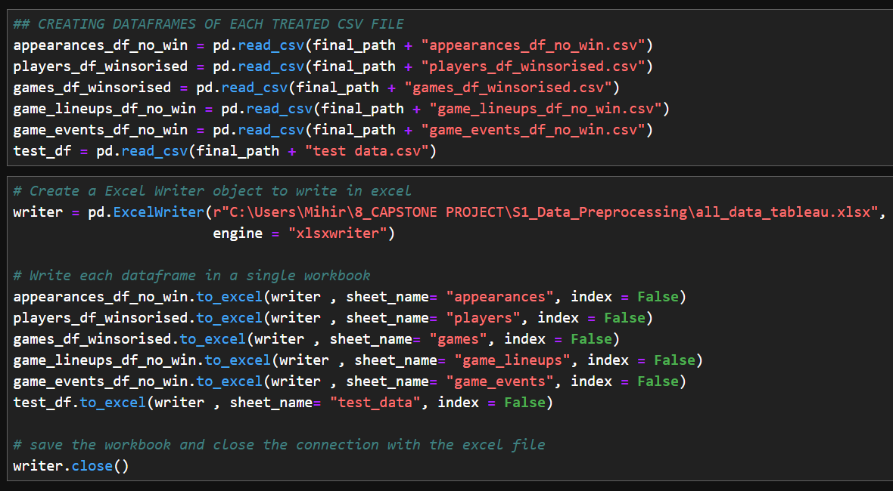

1. For the purpose of making visualization and dashboards, we create tableau relationship of these tables in the following way

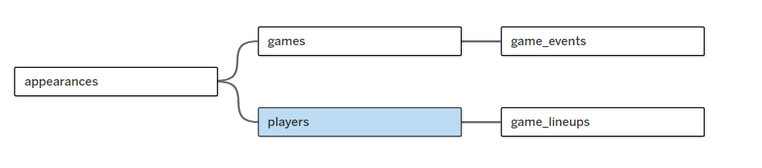

## Data Import for MySQL Server:

1. Using Python, we establish connection to our MySQL Server to store the treated data frames by creating a new database using MySQL connector module of Python

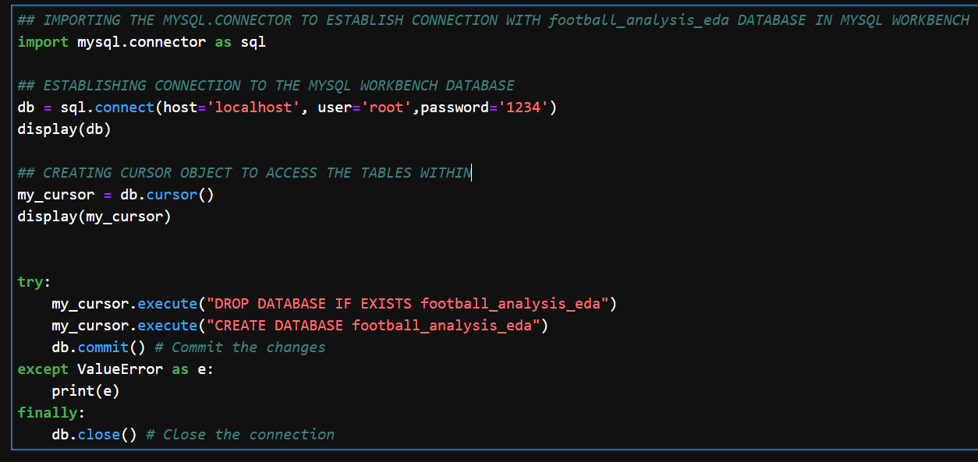

1. Using SQL Alchemy library of Python, we save the data frames the newly formed database ‘football_analysis_eda’

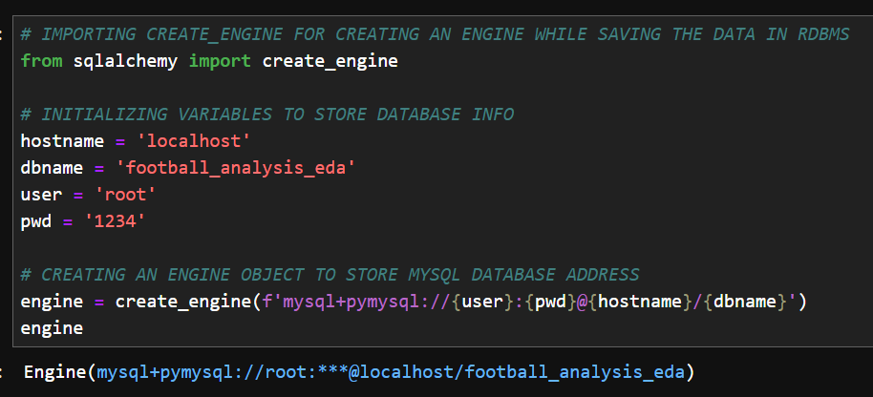

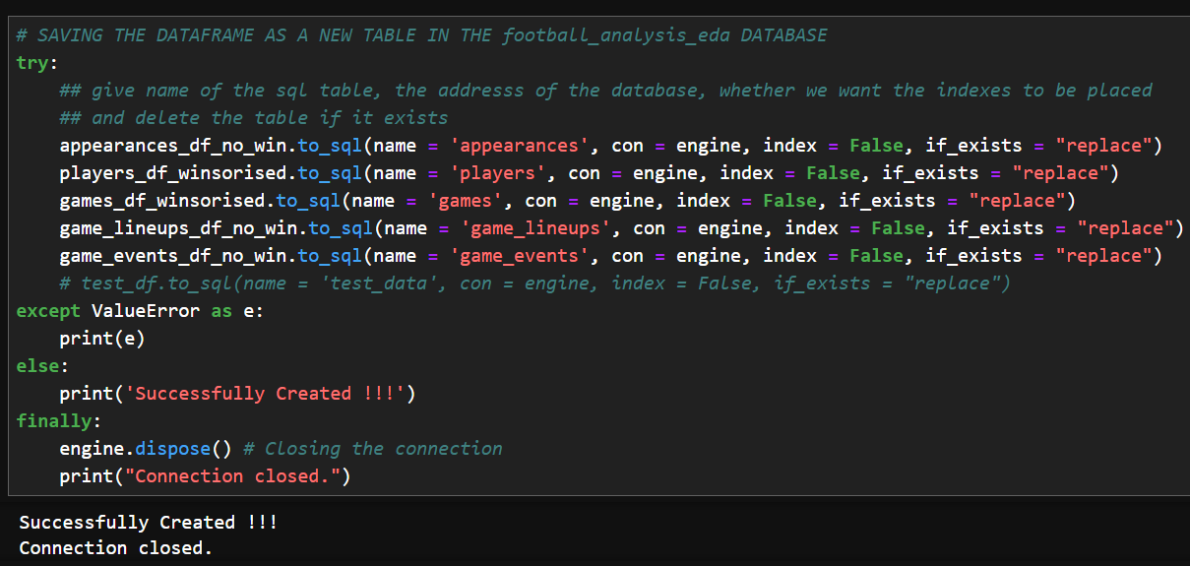

NOTE- BOTH THESE LIBRARIES ARE ALTERNATIVES AND ANY ONE CAN BE USED TO CONNECT, RETRIEVE AND CREATE OBJECTS IN MYSQL ENVIRONMENT THROUGH PYTHON

1. Business Objectives
   1. Performance Analysis
      1. Objective: Analyse individual player and team performance by goals, assists, cards.
2. Analysis
   1. Performance Analysis
      1. How does a player's performance vary across different seasons?
         1. Using Rows Ai Website to find insights   
            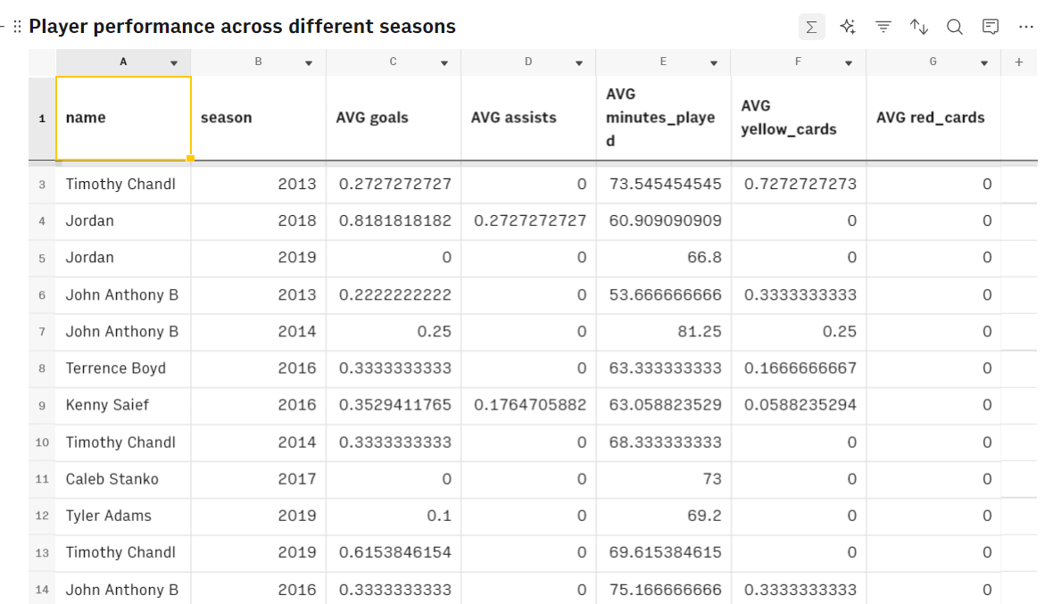
         2. Using Excel Pivot table to Build Charts  
            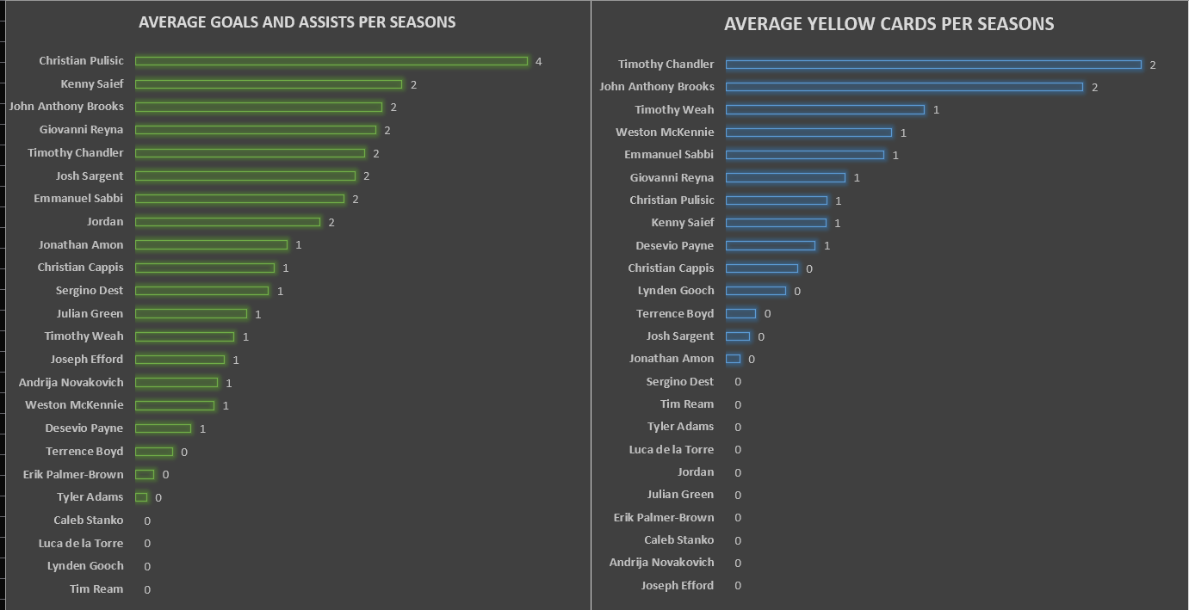
         3. Interpretation:
            1. **CHRISTIAN PULISIC HAS A VERY GOOD PERFORMANCE IN TERMS OF CONTRIBUTION TO THE TEAMS AND LOW NUMBER OF YELLOW CARDS HAS 4 AVERAGE GOALS AND**
            2. **ALTHOUGH JOHN ANTHONY BROOKS HAS AVERAGE OF 2 GOALS PER SEASON, THE NUMBER OF YELLOW CARDS RECEIVED SHOWS THAT THE PLAYER HAS TO IMPROVE ON HIS AGGRESSION (IN-GAME ATTITUDE) AND OR IMPROVE HIS GAME.**
      2. **On an Average what is the goals and assists for each player?**
         1. **Using Rows Ai Website to find relevant data**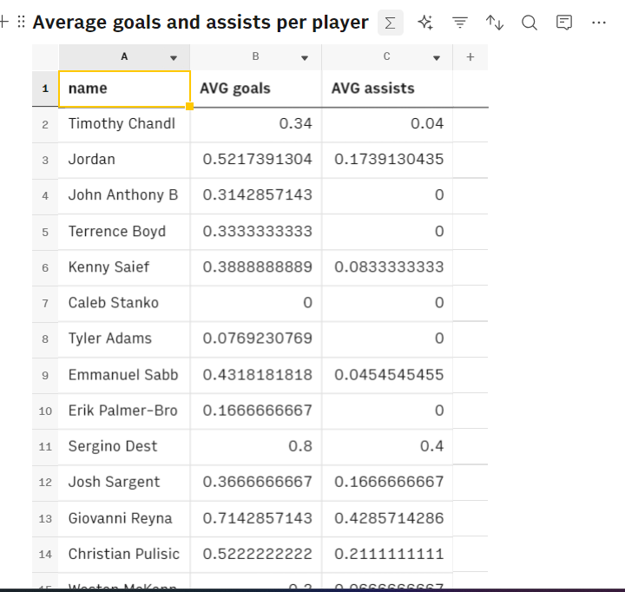
         2. **Using Excel’s Conditional Formatting to find the average contribution**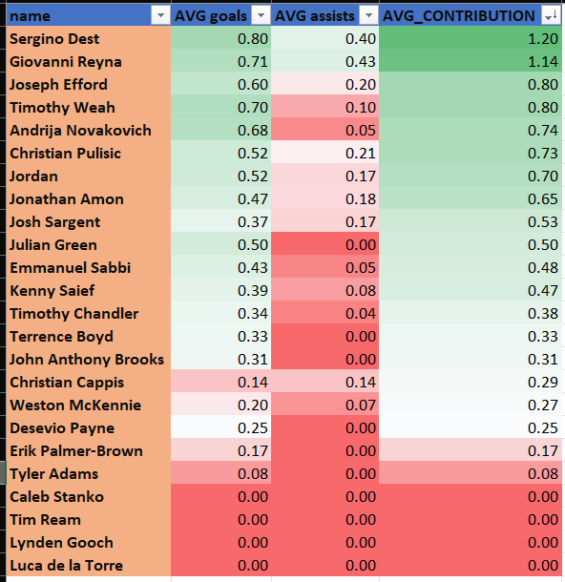
         3. **INTERPRETATION:**
            1. CHRISTIAN PULISIC AND KENNY SAIEF HAVE GREATER PERFORMANCE IN GAME AND LESSER NUMBER OF FOULS
            2. SERGINO DEST AND GIOVANNI REYNA HAVE GREATER PERFORMANCE ACROSS ALL SEASONS
            3. CHRISTIAN PULISIC AND KENNY SAIEF ARE PLAYERS WHO HAVE GREAT PERFORMANCE FOR SOME SEASONS
            4. WHILE SERGINO DEST AND GIOVANNI REYNA HAVE CONSISTENTLY OUT PERFORMED ALL PLAYERS IN ALL SEASONS
      3. Which players contribute the most in terms of goals, assists, and minutes played?
         1. Using MySQL to create a view   
            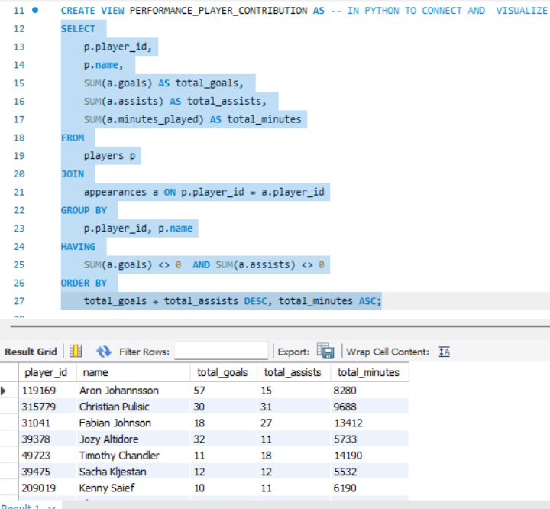
         2. Using Previously used MySQL Connector in python to visualise  
            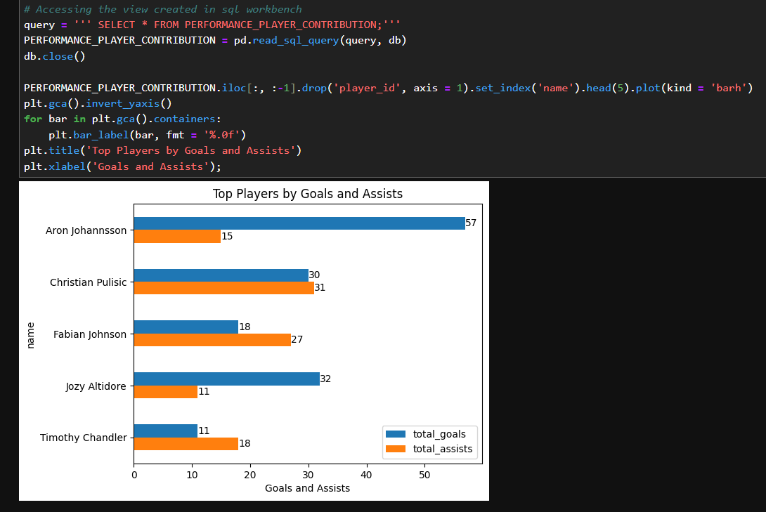
         3. INTERPRETATION:
            1. ARON JOHANSSON HAS MORE INCLINATION TOWARDS SCORING GOALS THAN ASSISTS 57 GOALS AND 15 ASSIST
            2. CHRISTIAN PULISIC HAS CONTRIBUTED ALMOST EQUALLY IN GOALS AND ASSISTS 30 GOALS AND 31 ASSISTS – MORE BALANCED PLAYER IN TERMS OF GOALS AND ASSISTS
            3. FABIAN JOHNSON HAS CONTRIBUTED MORE TOWARDS ASSISTS THAN GOALS, 18 GOALS AND 27 ASSISTS SHOWING MORE INCLINATION TOWARDS ASSISTING TEAM WIN
      4. What are the patterns of red and yellow cards for different players and teams?(4. Which players have most yellow and red cards?)
         1. Using MySQL to create view  
            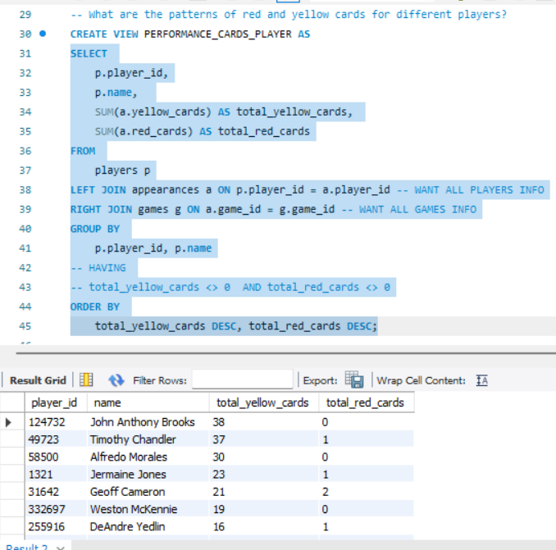
         2. Using Previously used MySQL Connector in python to visualise  
            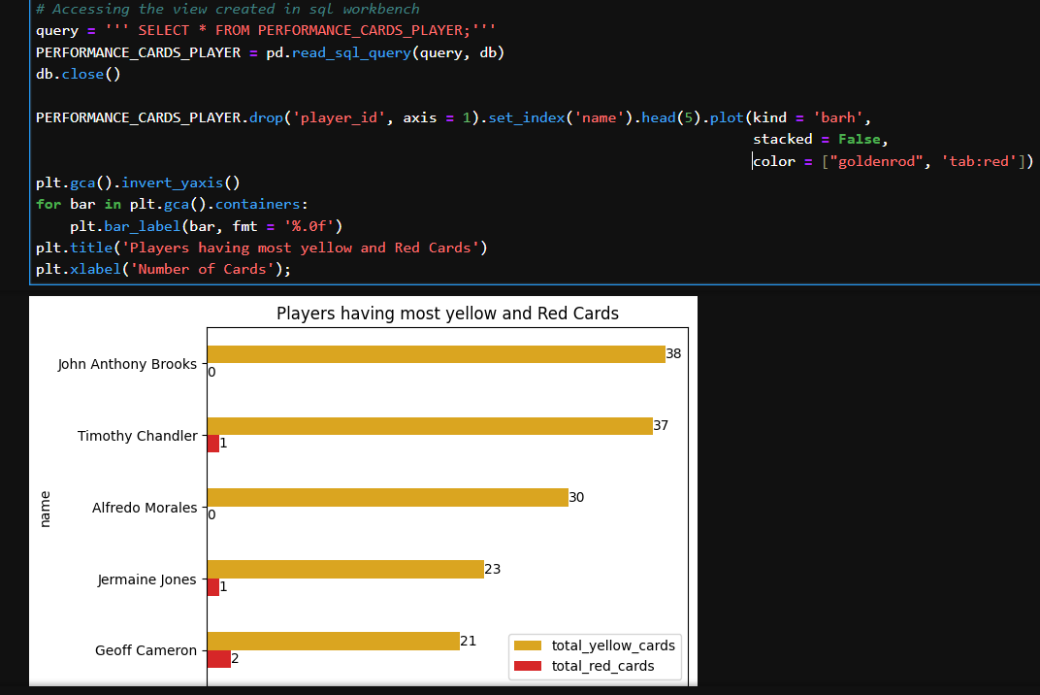
         3. INTERPRETATION:
            1. THESE SHOW THE TOTAL CARD TO PLAYERS
            2. AS PREVIOUSLY SEEN JOHN ANTHONY BROOKS AND TIMOTHY CHANDLER HAVE 38 YELLOW CARDS AND 37 YELLOW, 1RED CARD RESPECTIVELY
            3. THESE PLAYERS NEED TO IMPROVE **PLAYER HAVE TO IMPROVE ON THEIR AGGRESSION (IN-GAME ATTITUDE) AND IMPROVE THEIR GAME.**
      5. 1. Which players contribute most to team victories through goals?  
         Assuming that the home and away goals are given in the games tables are as per players and as per the teams
         1. Using Python we delve into deeper analysis by merging game events and games data set on player id, filter the data where the home teams goals are more than away teams goals for each player  
            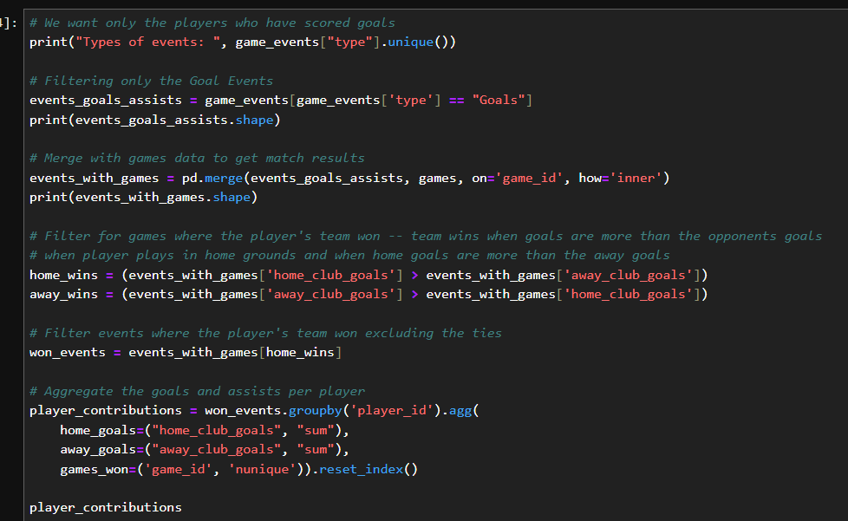

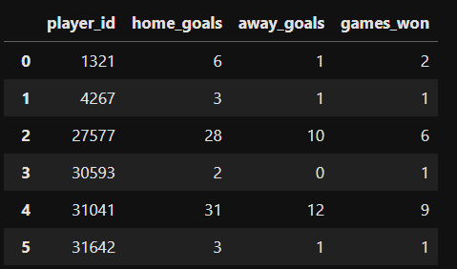

* + - 1. Get the player names for these player id from players table by merging this newly framed table with players on player id   
         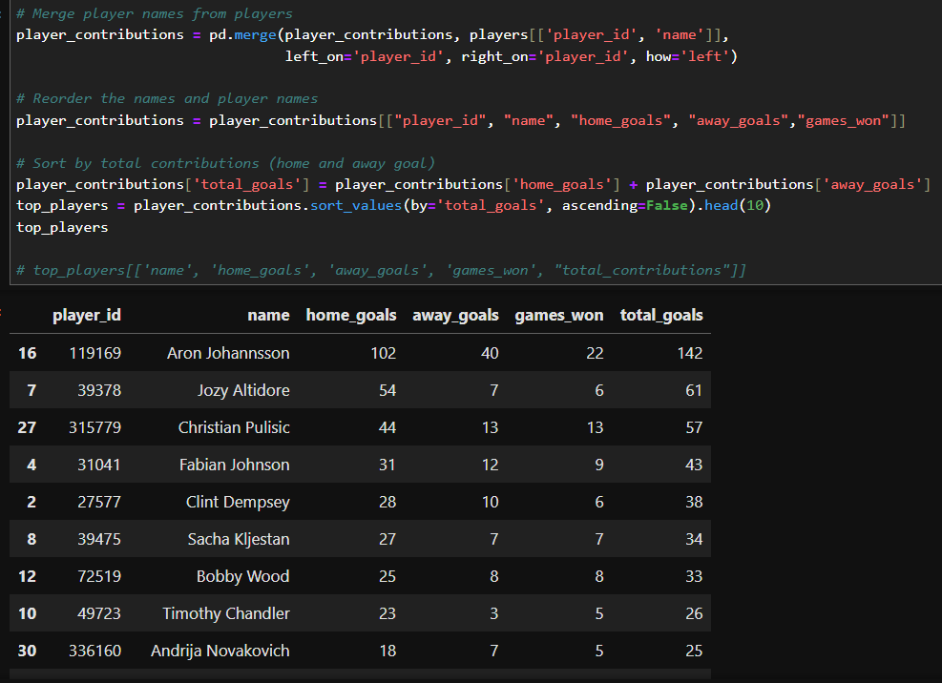
      2. Visualizing the Player who have contributed to home teams victory   
         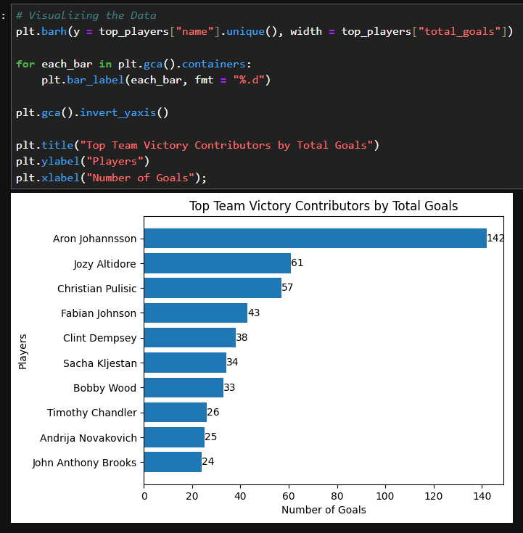
      3. INTEPRETATIONS:
         1. ARON JOHANNSSON HAS CLEARLY HELPED WIN 22 TEAMS WIN WITH HELP OF 142 GOALS SCORED ACROSS VARIOUS COMPETITIONS AND SEASONS
         2. CHRISTIAN PULISIC IS SECOND TO ARON JOHANNSSON WHO HAS HELPED 13 TEAMS WIN WITH 57 GOALS SCORED ACROSS VARIOUS COMPETITIONS AND SEASONS
         3. FABIAN JOHNSON IS THIRD TO ARON JOHANNSSON WHO HAS HELPED 9 TEAMS WIN WITH 43 GOALS SCORED ACROSS VARIOUS COMPETITIONS AND SEASONS
    1. How does the performance of key players impact the overall success of the team?
       1. Using Python to find out the winning percent of players found from iii question and merge the data with appearance tables and to filter the data when the home team has won and key players have played which is stored in python dictionary   
          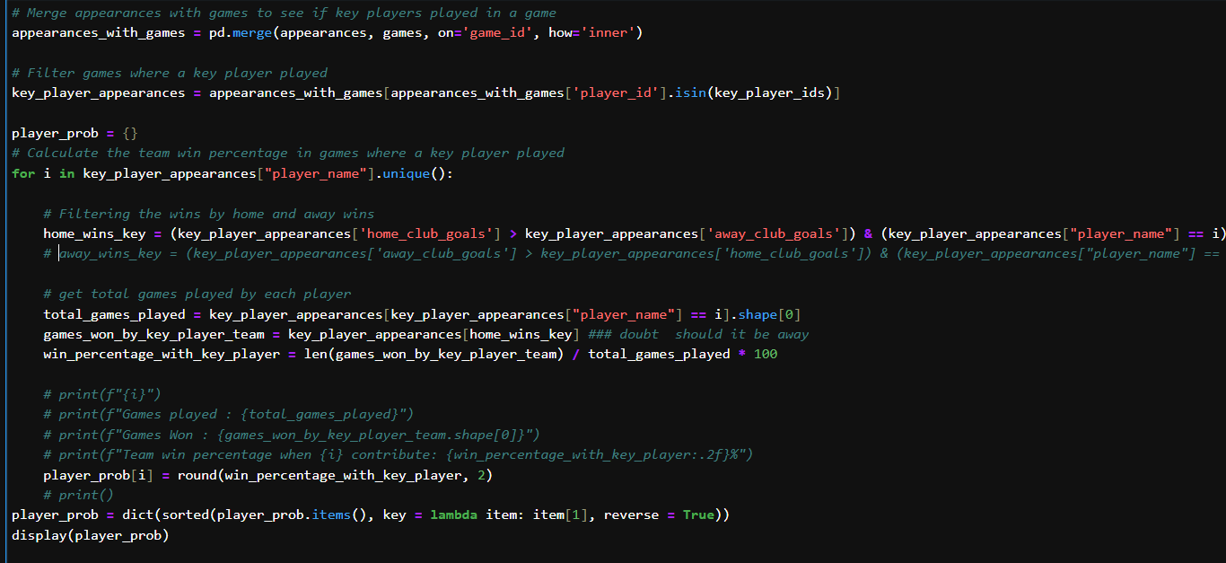
       2. Plotting The percentage of team winning where key players are present  
          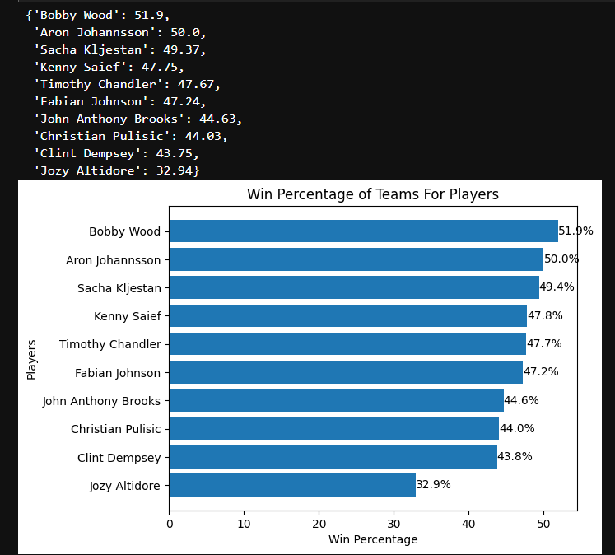
       3. INTERPRETATIONS:
          1. THERE IS SIGNIFICANT IMPACT OF EACH KEY PLAYERS IN WINNING A TEAM
          2. THERE IS AROUND 50 % CHANCE OF WINNING WHEN KEY PLAYERS PLAY FOR THE TEAM
          3. THE DIFFERENCE IS BETWEEN WINNING AND LOSING IF A KEY PLAYER IS NOT PRESENT FOR THE GAME
    2. How do teams perform when playing at home versus away?
       1. Using Python to get the total goals, games played, and games won percentage for each team at home and away   
          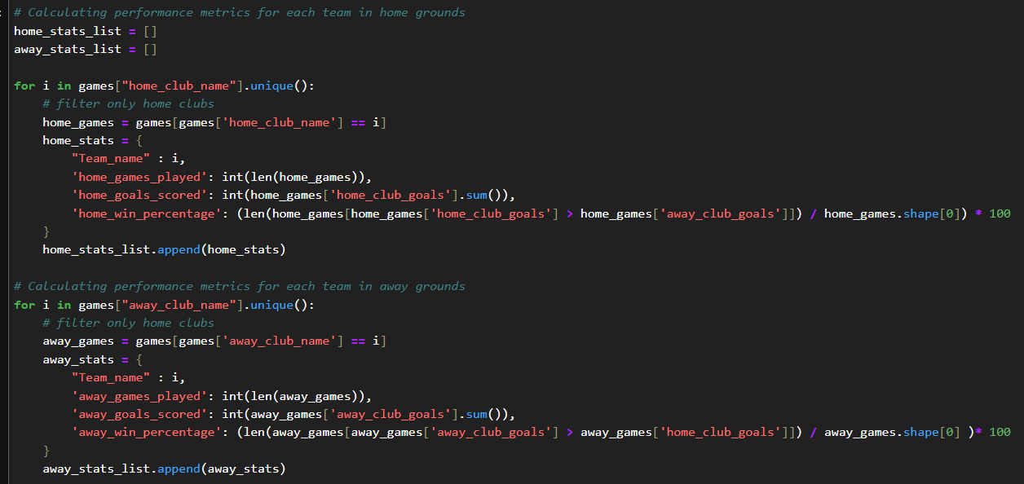
       2. Converting the relevant data into Data frame to visualize a heatmap by games played and game win percent for top teams  
          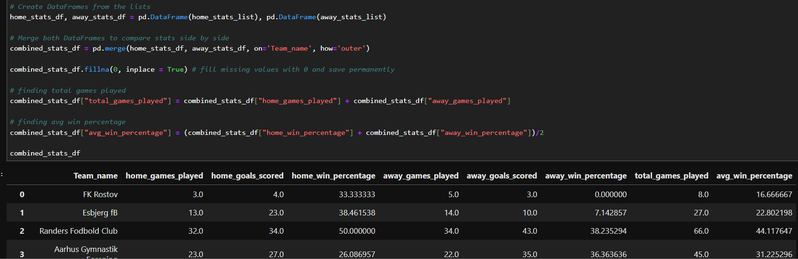

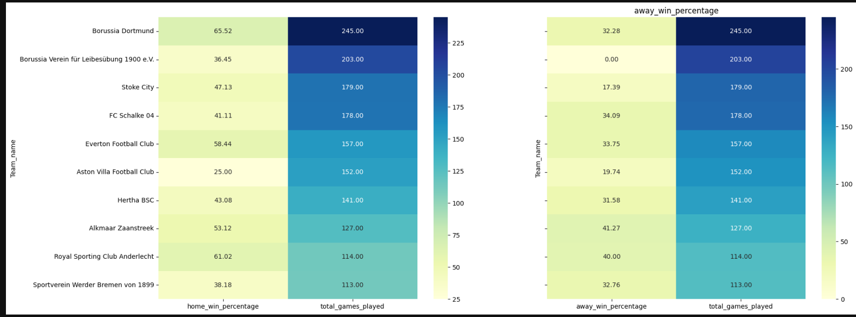

* + - 1. INTERPRETATIONS:
         1. BASED ON THE MORE THAN 100 GAMES PLAYED THERE WE CAN COMPARE THAT FOR EACH TEAM THE WIN PERCENT IS HIGHER THAN THAT
    1. What is the probability of a player making an assist given that the match is in a specific competition (e.g., Domestic League)? (conditional probability)
       1. Using Python to find number of games played and total assists given in the game to get the assist probability for each competition type  
          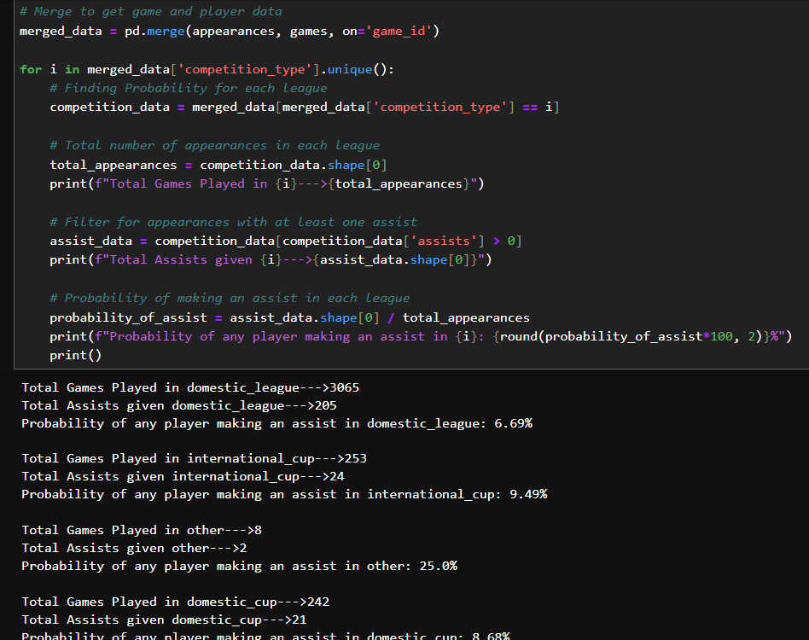
       2. INTERPRETATIONS:
          1. PROBABILITY OF ASSISTING A PLAYER IS 25 % IN OTHER COMPETITION TYPE
          2. IN DOMESTIC LEAGUE IT IS 6.69%
          3. IN INTERNATIONAL CUP IT IS 9.49%
          4. IN DOMESTIC CUP IT IS 8.68%
    2. What is the probability of scoring a goal given that the player is playing in a forward position? (conditional)
       1. Using Python to find number of games played and total goals scored for each position and sub-position  
          position  
          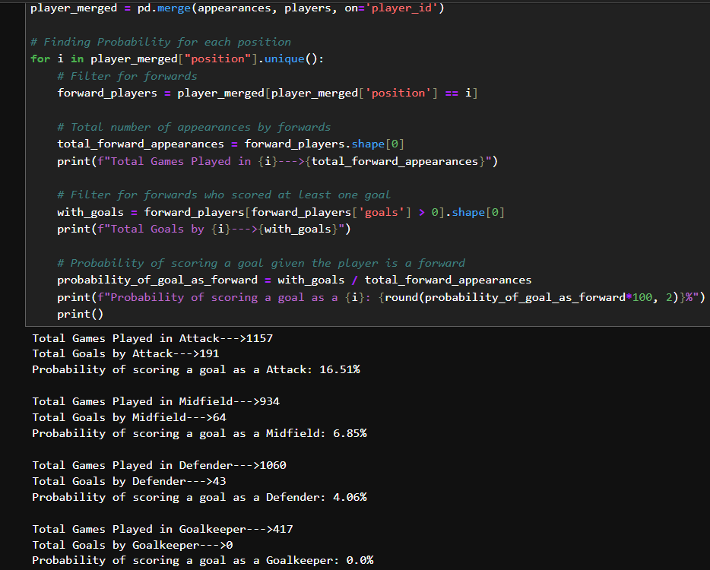  
          sub position  
          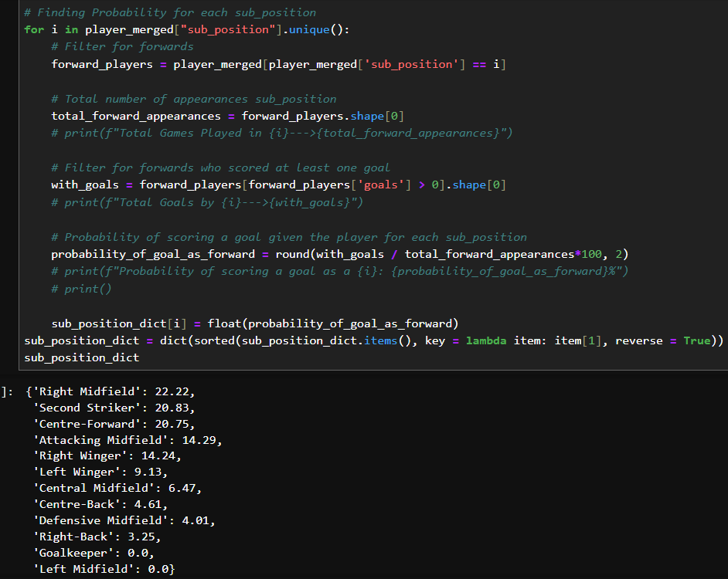
       2. INTERPRETATIONS:
          1. ATTACK POSITION PLAYERS ARE MORE LIKELY TO SCORE A GOAL THAN OTHER POSITIONS WITH 16.51%
          2. MIDFIELD HAS 6.85%
          3. DEFENDER HAS 4.06% AND GOALKEEPER HAS 0.00%
          4. IN SUPOSITIONS, RIGHT MIDFIELD PLAYERS ARE MORE LIKELY TO SCORE A GOAL THAN OTHER SUBPOSITIONS WITH 22.22%
          5. 'Second Striker': 20.83%
          6. 'Centre-Forward': 20.75%
          7. 'Attacking Midfield': 14.29%
          8. 'Right Winger': 14.24%
          9. 'Left Winger': 9.13%
          10. 'Central Midfield': 6.47%
          11. 'Centre-Back': 4.61%
          12. 'Defensive Midfield': 4.01%
          13. 'Right-Back': 3.25%
          14. 'Goalkeeper': 0.0%
          15. 'Left Midfield': 0.0%
    3. What is the joint probability of a player playing more than 50 minutes and getting at least one assist in a given season? (joint probability)
       1. Using python to filter the data more than 50 minutes and at least 1 assists given   
          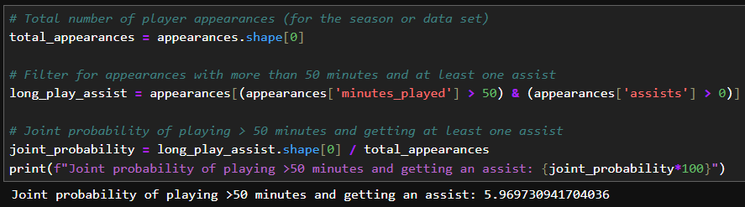
       2. INTERPRETATIONS:
          1. IT IS VERY UNLIKELY THAT A PLAYER CAN HELP PLAYERS ASSIST IN SCORING A GOAL. THE CHANCES ARE 5.96%
          2. AFTER 50 MINUTES MARK, DUE TO EXHAUSTIONS, THE PLAYER MAY NOT BE ABLE TO ASSIST IN SCORING GOALS
    4. How can we create a representative sample of matches to assess overall team performance over a season? (clt)
       1. Using python to assess whether the home club goals and away club goals follow normal distribution  
          home clubs  
          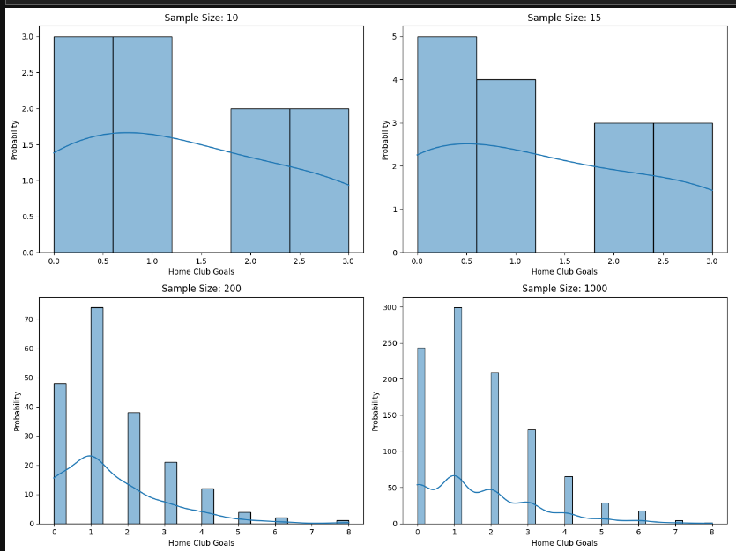  
          away clubs  
          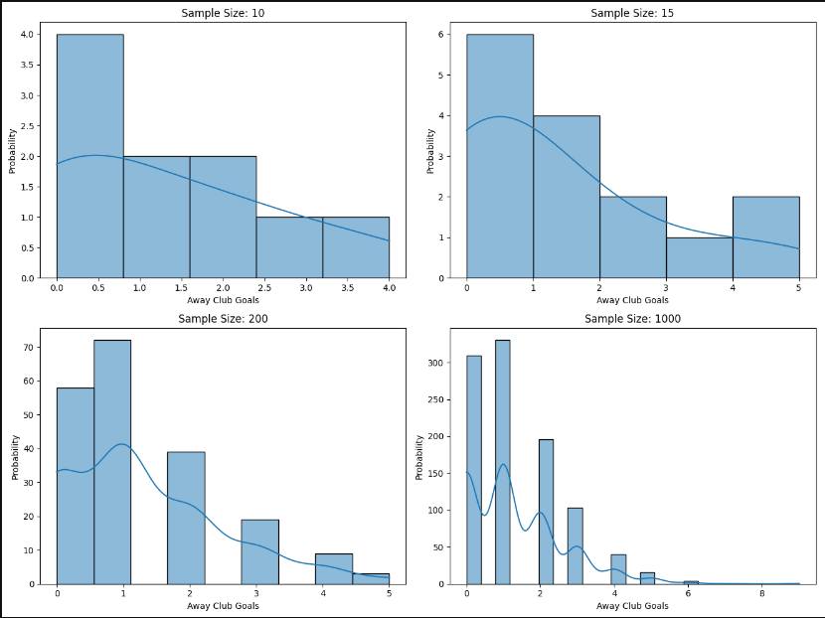
       2. INTERPRETATIONS:
          1. AS THE SAMPLE SIZE INCREASES BEYOND 30 SAMPLES FOR BOTH HOME AND AWAY CLUB GOALS WE SEE THAT THE DISTRIBUTIONS TENDS TO FOLLOW NORMAL DISTIBUTIONS
          2. DUE TO LACK OF SAMPLES, WE SEE A SKEWED DISTRIBUTION
    5. Can we predict if a player will receive a yellow card based on their previous performance metrics? (MACHINE LEARNING MODEL)
       1. Using Python, We try to predict whether the player will receive a yellow card based on the goals, assists and minutes played  
          Using multiple logistic regression  
          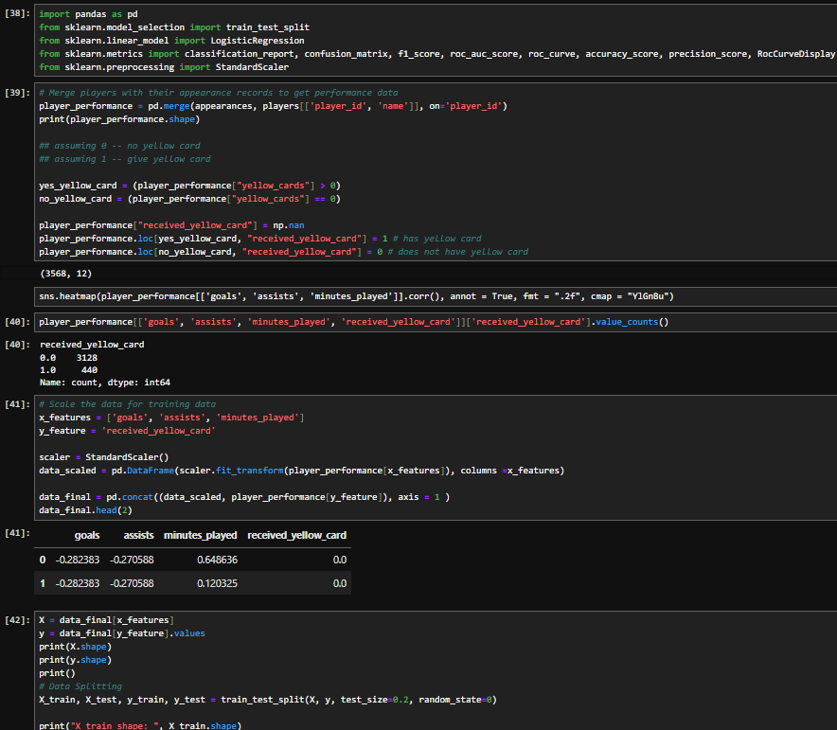  
          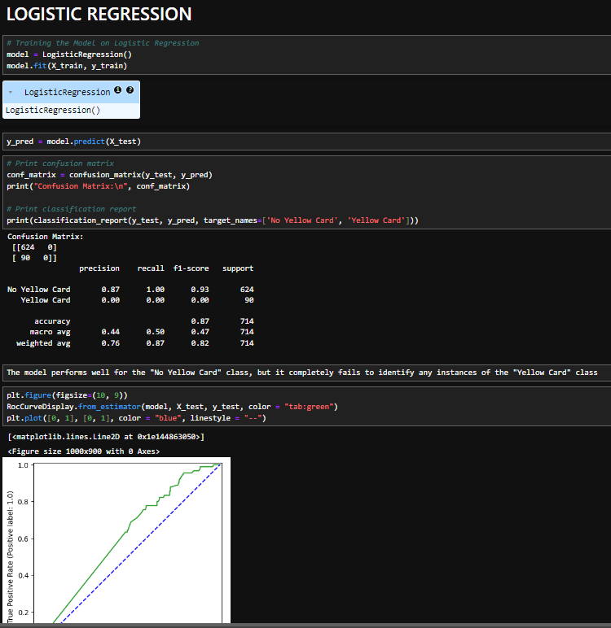
       2. INTERPRETATIONS:
          1. THROUGH MODEL WE CAN SEE THAT MODEL HAS 87% PRECISION TO PREDICT PLAYERS WHO WILL NOT RECEIVE YELLOW CARDS
          2. MODEL COMPLETELY FAILS TO PREDICT PLAYERS WHO WILL NOT RECEIVE YELLOW CARD

* 1. PLAYER PROFILE AND MARKET TRENDS
     1. How does player age impact their market value?
        1. Using Python to calculate Age by subtracting the current year from the year of birth of the players and visualizing correlation scatter plot between age and market value with details of the player position  
           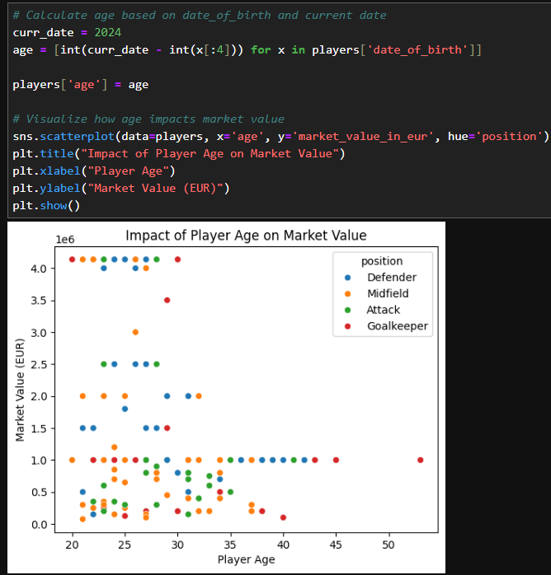  
           Linear Regression Model to Check the fit of line  
           Using ChatGPT to plot the below chart  
           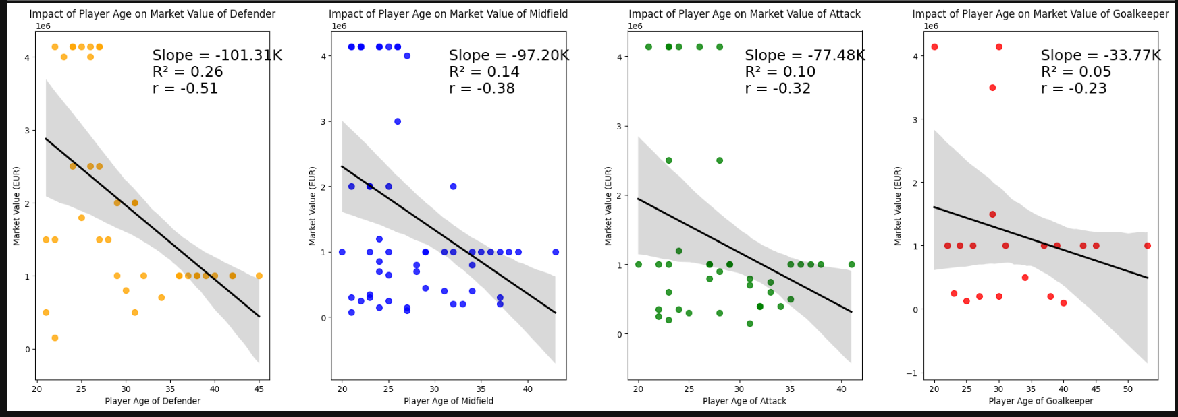
        2. INTERPRETATIONS:
           1. THERE IS A HIGH NEGATIVE CORRELATION BETWEEN AGE AND MARKET VALUE THAT IS AS AGE INCREASES BEYOND 30 YEARS THE MARKET VALUE HAS A SUBSTANTIAL DROP
           2. MARKET VALUE OF DEFENDER FALLS BY 100 K EUROS EVERY YEAR, r = -0.51, r2 = 0.26
           3. MARKET VALUE OF MIDFIELD BY 97 K EUROS, r = -0.38, r2 = 0.14
           4. MARKET VALUE OF ATTACKERS BY 77 K EUROS r = -0.32, r2 = 0.10
           5. MARKET VALUE OF GOALKEEPERS BY 33 K EUROS r = -0.23, r2 = 0.05
     2. Which players have the highest market value, and are they performing up to that value?
        1. Using Python to merge players and appearances and comparing the contributions and highest market value  
           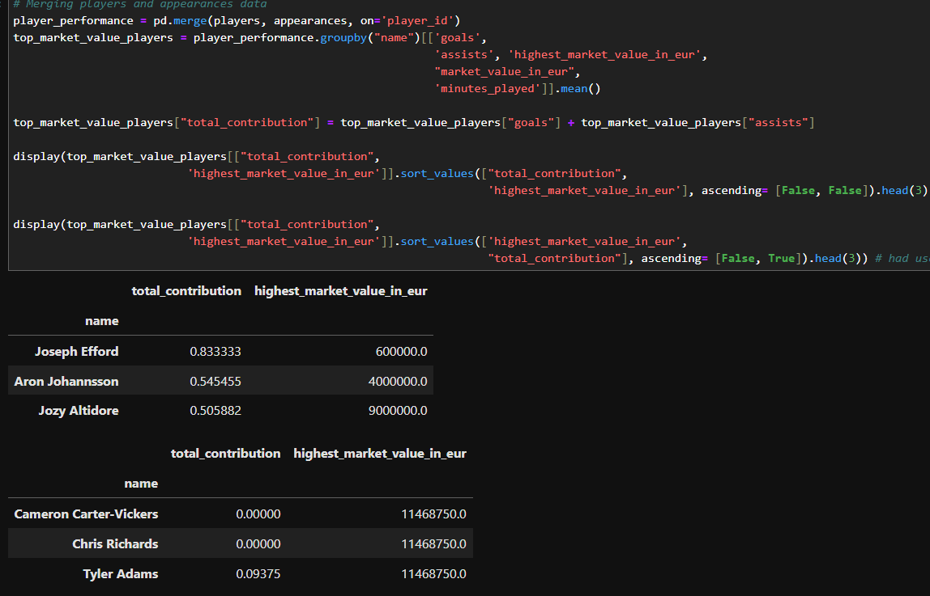
        2. INTERPRETATIONS:
           1. CAMERON CARTER-VICKERS, CHRIS RICHARDS TYLER ADAMS HAVE HIGH MARKET VALUE AND THEIR TOTAL CONTRIBUTION IS EQUAL TO 0 PER MATCH.
           2. JOSEPH EFFORD, ARON JOHANNSSON, JOZY ALTIDORE HAVE LOW MARKET VALUE AND TOTAL CONTRIBUTION IS MORE THAN 0.5 PER MATCH
           3. SHOW THAT THE POTENTIAL OF PLAYERS ARE NOT GAUGED BY THE PERFORMANCE IN THE MATCH
     3. How does a player’s performance influence their current market value?
        1. Using Python to merge players goals, assists, minutes played in each matches and plot a correlation matrix   
           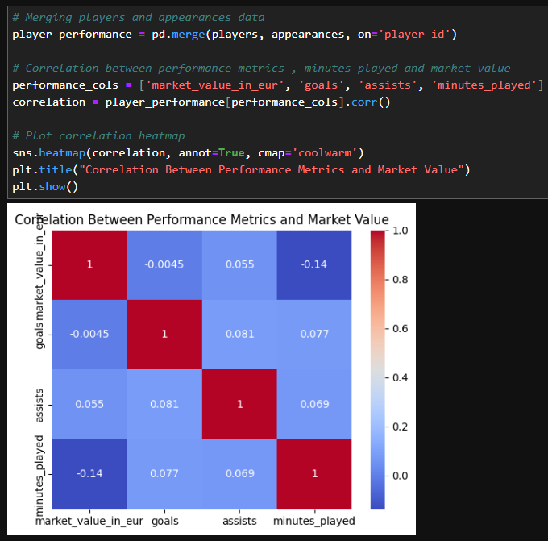
        2. Also Using Multiple Linear Regression to predict the market value based on the goals, minutes played and assists made by player  
           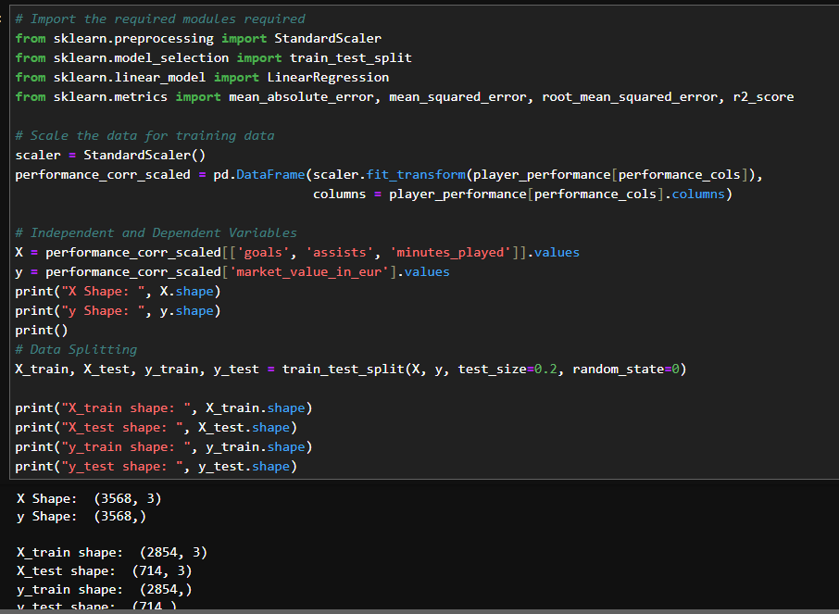  
           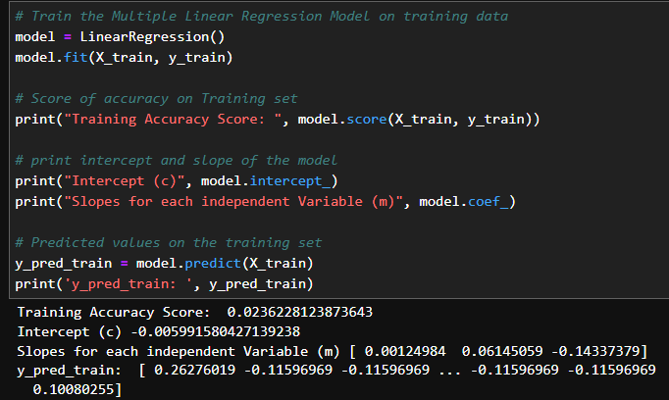  
           Using ChatGPT to plot scatter plot and regression line   
           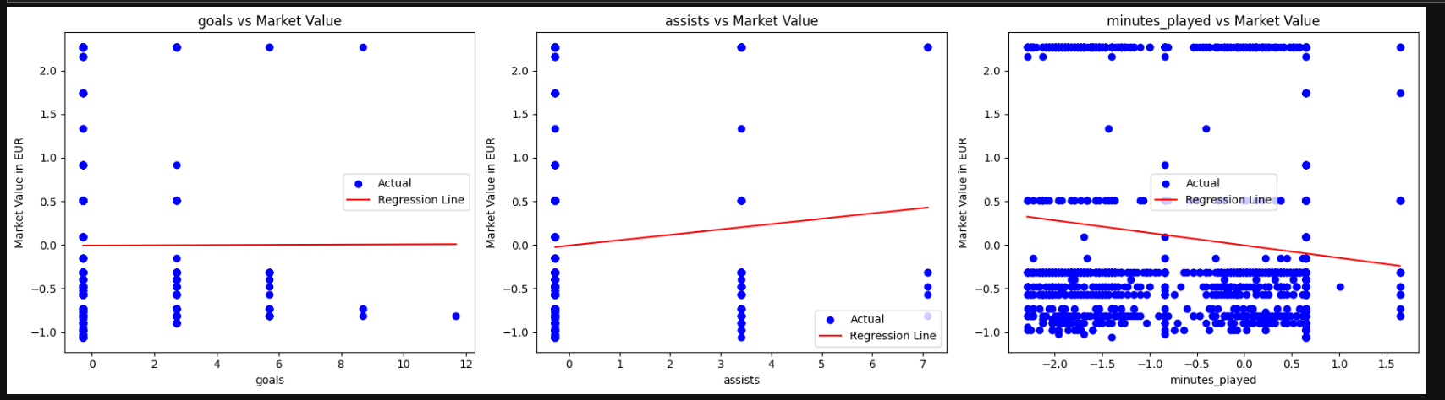
        3. INTERPRETATIONS:
           1. THE CORRELATION MATRIX BETWEEN MARKET VALUE IN EUROS, GOALS, ASSISTS, MINUTES PLAYED SHOW VERY LOW CORRELATIONS NEARLY EQUAL TO 0
           2. FURTHER THE LINEAR REGRESSION MODEL IS HAS VERY TRAINING SCORE OF 0.0236
     4. Which positions or sub-positions tend to have higher market values?
        1. Using MySQL to create a view   
           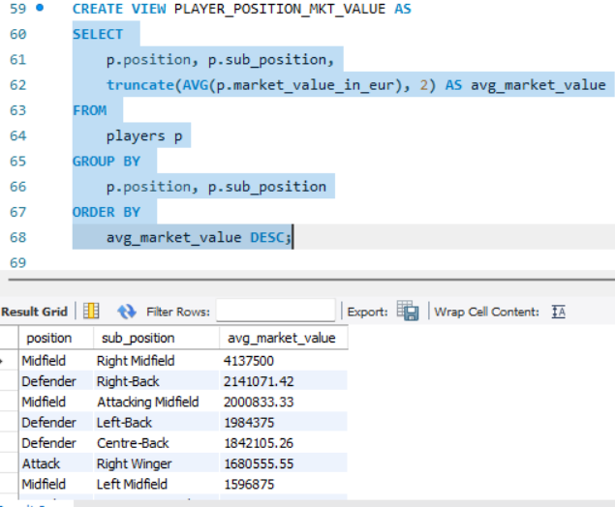
        2. Using Previously used MySQL Connector in python to visualise  
           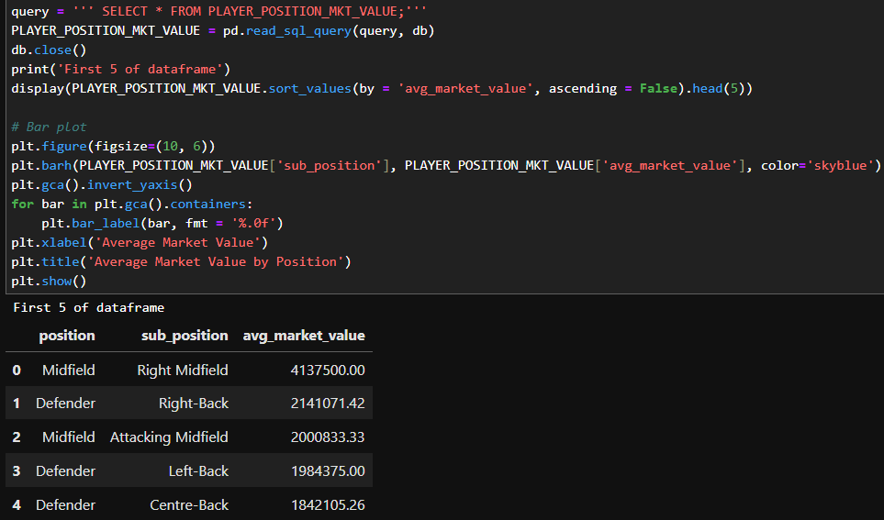  
           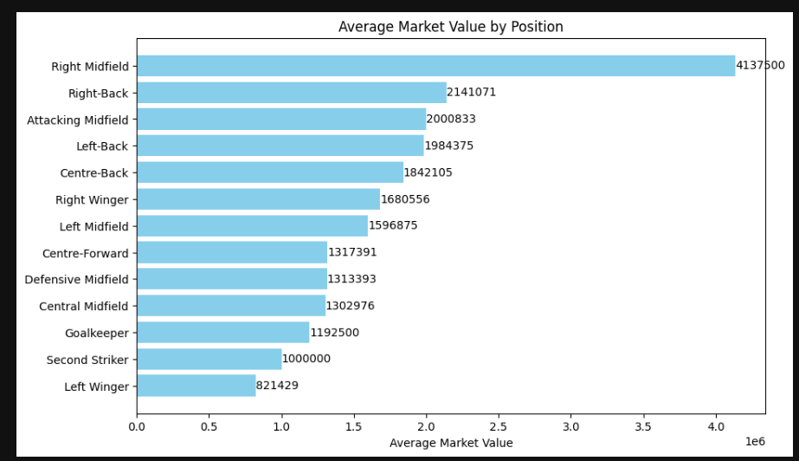  
           FOR PRESENTATION PURPOSE IN PPT USED TREEMAP FROM EXCEL CHARTS  
           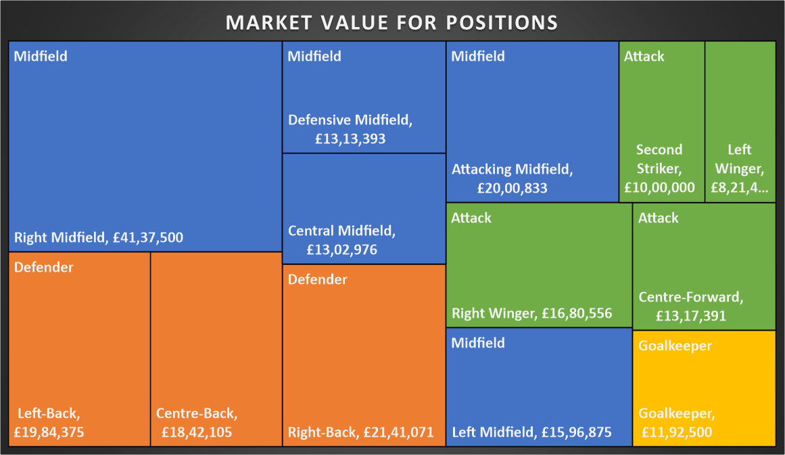
        3. INTERPRETATIONS:
           1. RIGHT MIDFIELDERS ARE PAID THE MOST OUT OF ALL PLAYER POSITIONS
     5. Is there any correlation between a player's height, market value?
        1. Using MySQL to create views   
           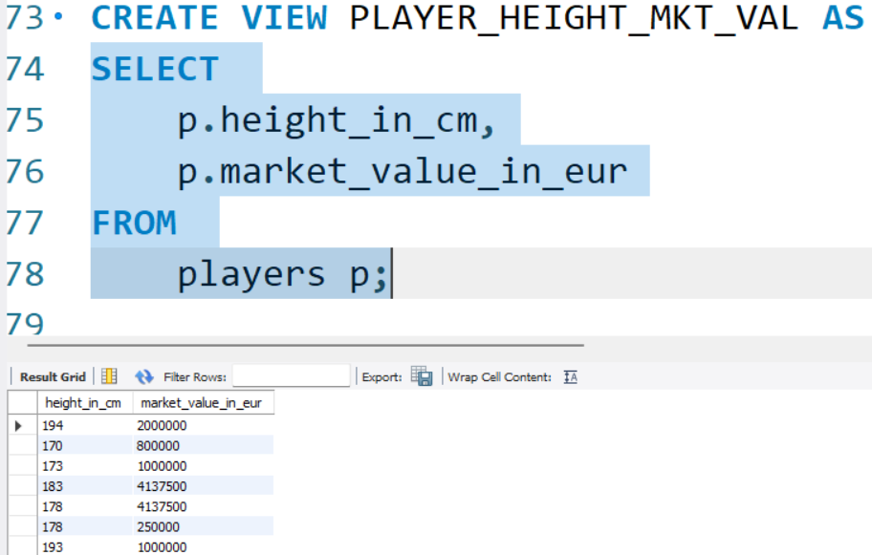
        2. Using Previously used MySQL Connector in python to visualise  
           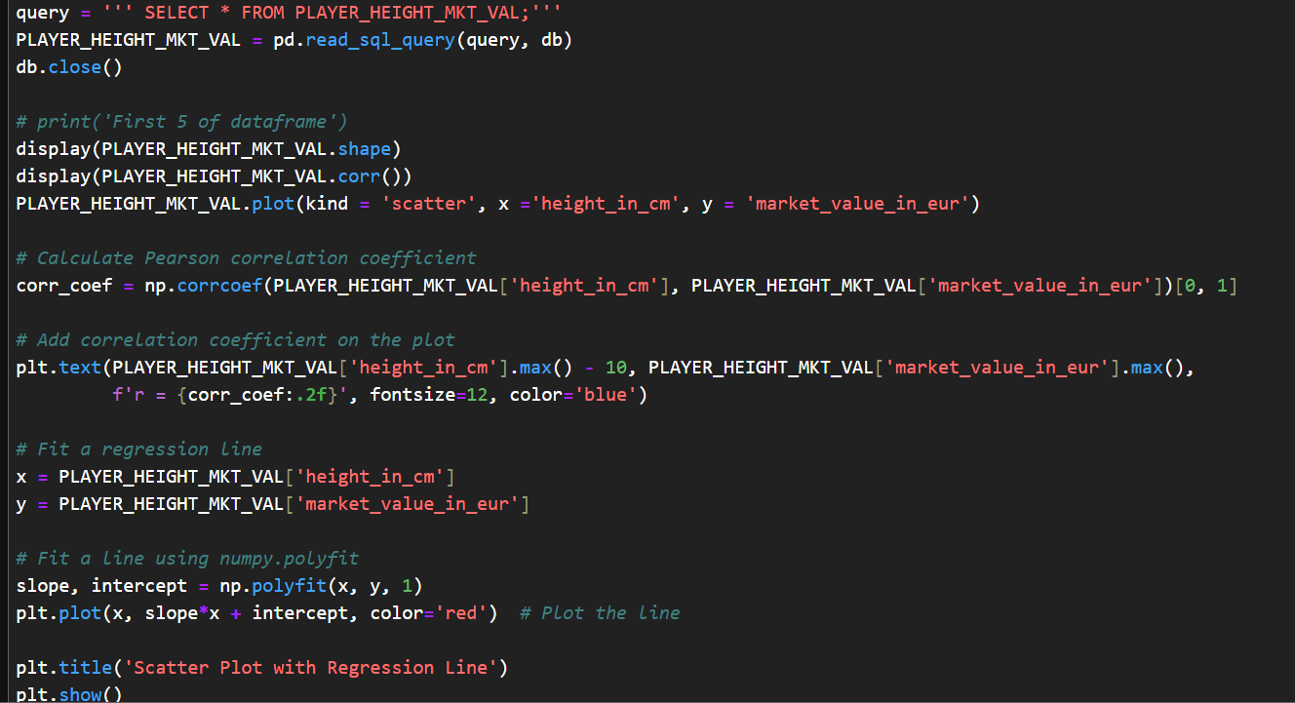  
           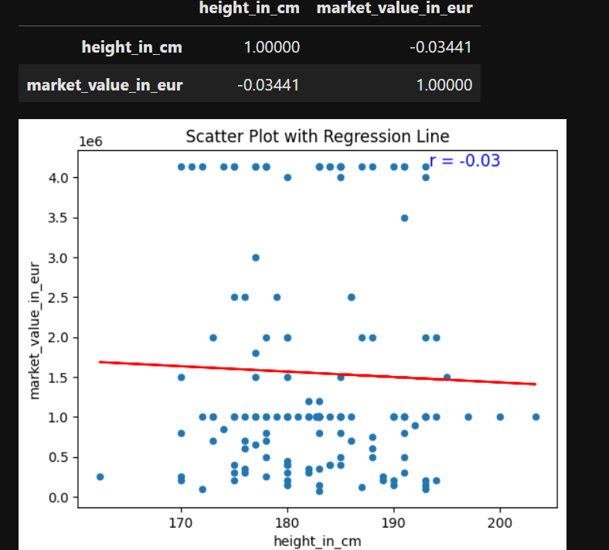
        3. INTERPRETATIONS:
           1. THERE IS VERY ALMOST 0 CORRELATION BETWEEN HIEGHT OF THE PLAYER AND MARKET VALUE correlation coefficient (r) is -0.03
     6. Which players should the club invest in based on future potential and market demand?
        1. Using Python to extract the information by merging players and appearance tables getting player details and market values  
           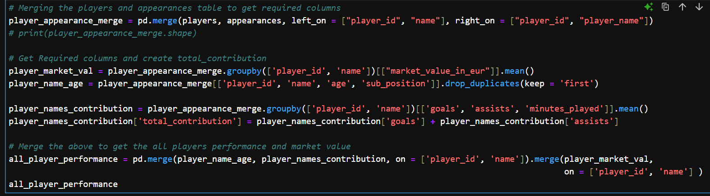  
           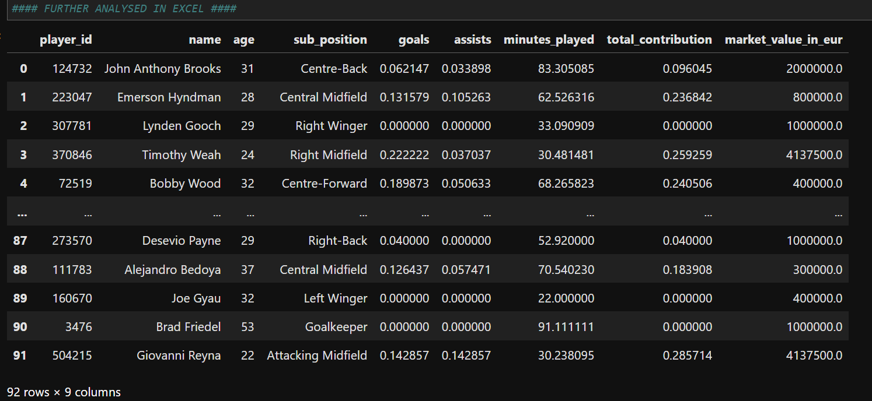
        2. Using Excel to present a colour scaled table of investable players based on future potential  
           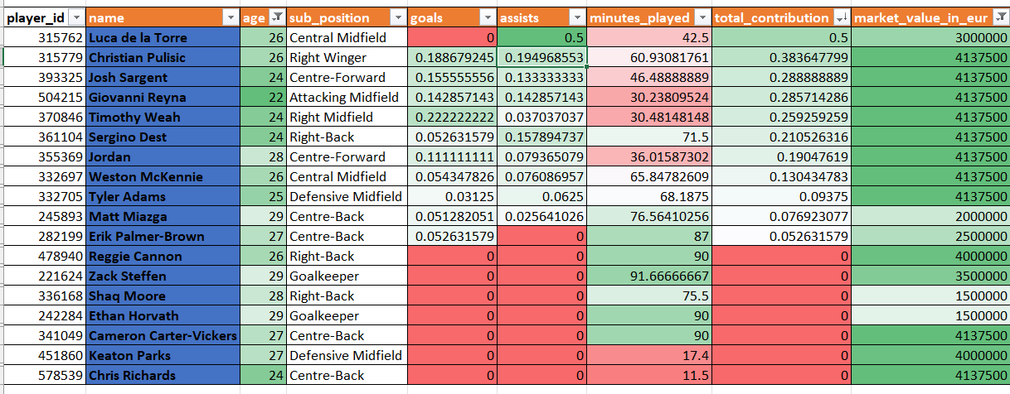  
           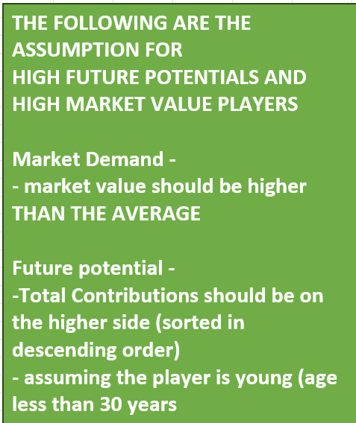
        3. INTERPRETATIONS:
           1. CHRISTIAN PULISIC HAS A SIGNIFICANT CONTRIBUTION IN TERMS OF BOTH GOALS AND ASSISTS (0.188 AND 0.194 RESPECTIVELY) IN MATCHES WITH 60 MINUTES PLAYED ON AVERAGE AND MARKET VALUE OF 4137500
           2. LUCA DE LA TORRE HAS CONTRIBUTED MOST IN TERMS OF ASSISTS WITH LEAST MINUTES (42.5 MINS) PLAYED ON AVERAGE WITH MARKET VALUE OF 300000 ALTHOUGH 0 GOALS ARE SCORED BY HIM ON AVERAGE DUE TO FACT OF THE PLAYER POSITIONING AS CENTRAL MIDFIELD, HE CAN BE TRAINED TO PLAY ON THE ATTACK SIDE AS RIGHT WINGER OR CENTER FORWARD
           3. JOSH SARGENT, GIOVANNI REYNA, TIMOTHY WEAH, SERGINO DEST HAVE GREAT POTENTIAL WITH ALMOST IDENTICAL MARKET VALUES, CONTRIBUTION TO CHRISTIAN PULISIC
  2. TEAM COMPARISON
     1. Using MySQL to create view for each questions and connecting the data using mysql connector  
        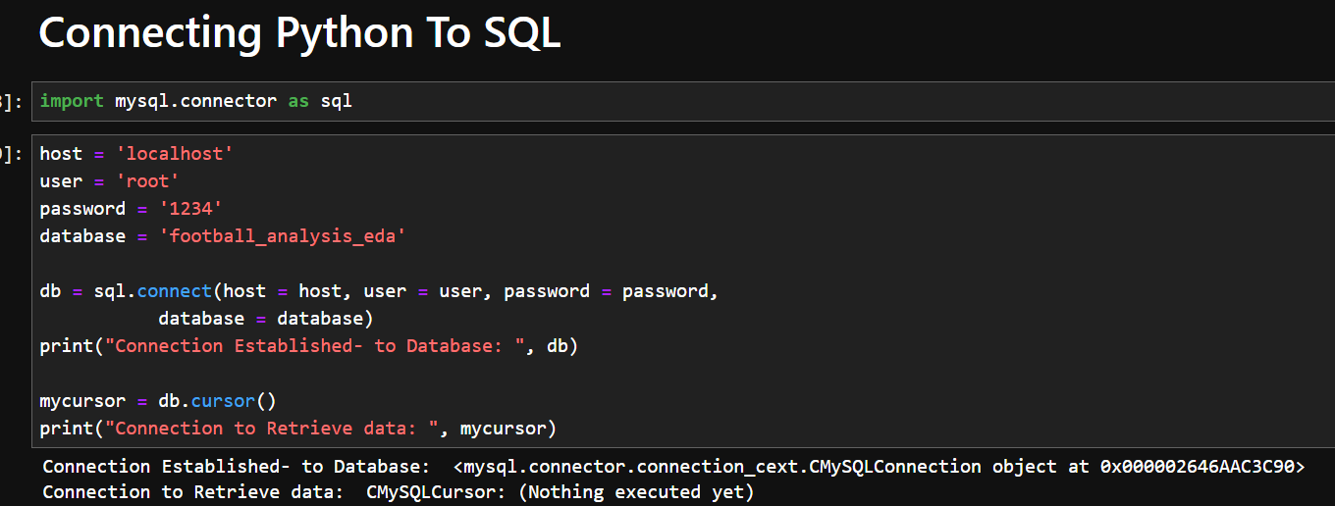  
        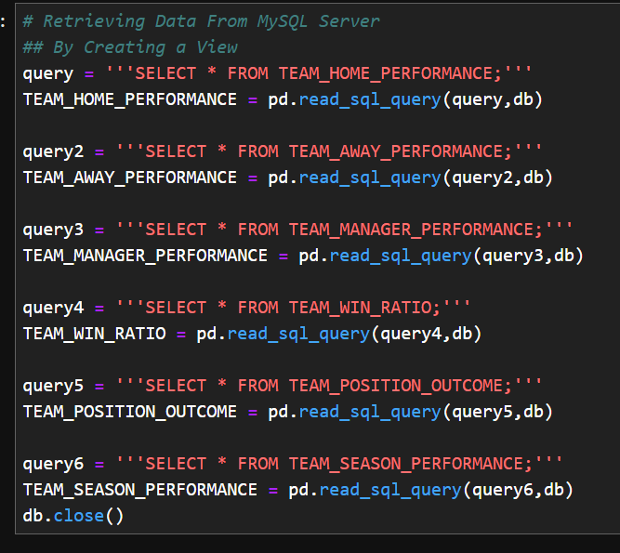
     2. How do teams compare based on goals scored in home and away games?
        1. 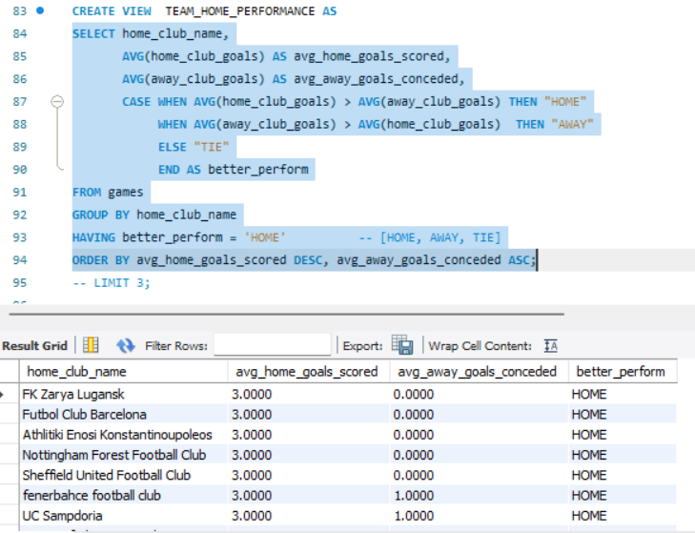
        2. 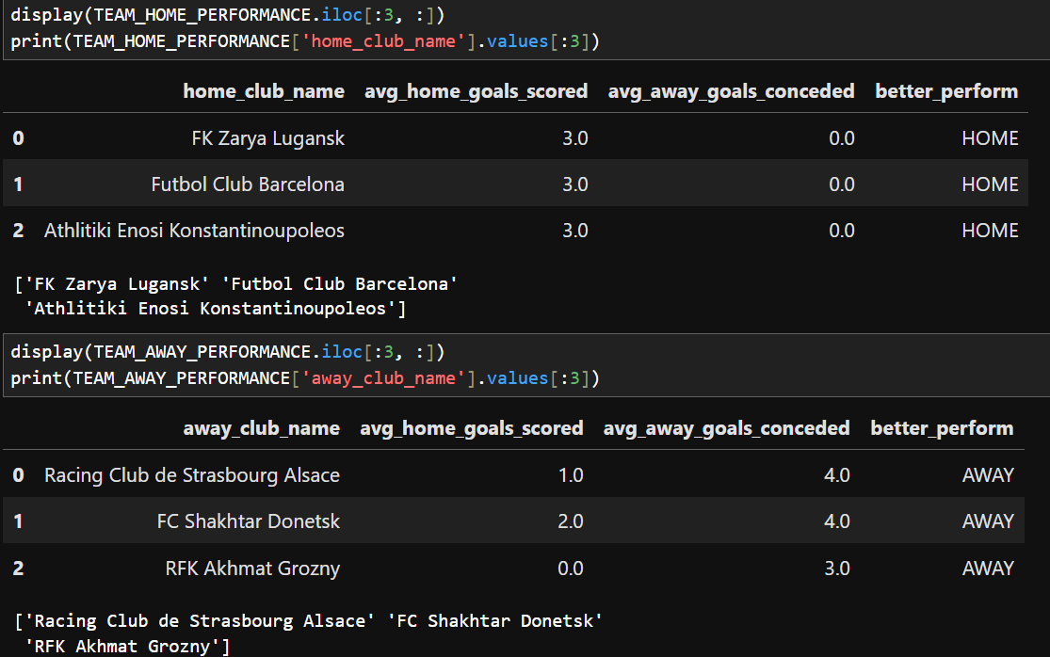

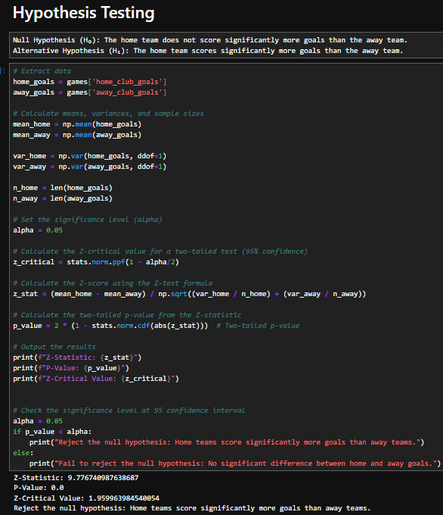

* + - 1. INTERPRETATIONS:
         1. 'FK ZARYA LUGANSK' ,'FUTBOL CLUB BARCELONA', 'ATHLITIKI ENOSI KONSTANTINOUPOLEOS' PLAY BETTER AT HOME WIN AVERAGE 3 GOALS AND 0 GOALS CONCEDED TO AWAY TEAM
         2. 'RACING CLUB DE STRASBOURG ALSACE', 'FC SHAKHTAR DONETSK', 'RFK AKHMAT GROZNY' PLAY BETTER AT AWAY WITHN AVERAGE 4 GOALS AND 1 GOALS CONCEDED TO HOME TEAM
    1. What are the differences in team performance based on manager names or strategies?
       1. 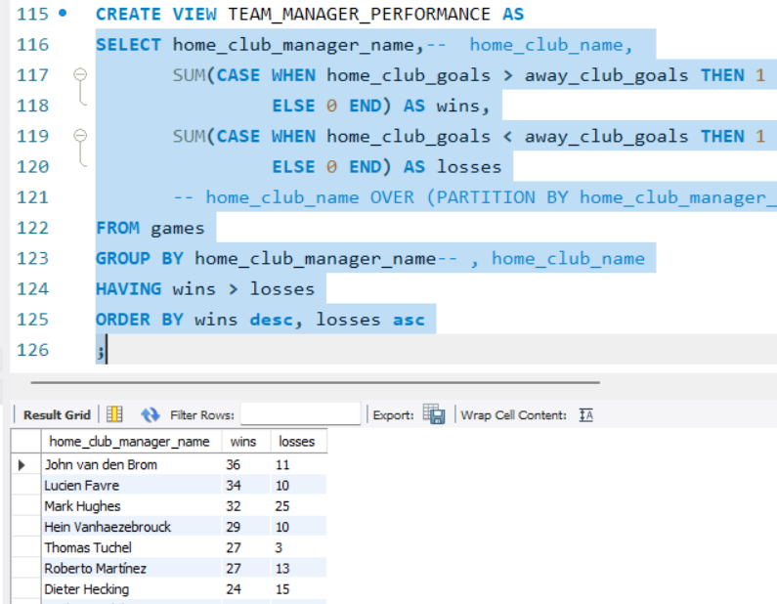
       2. 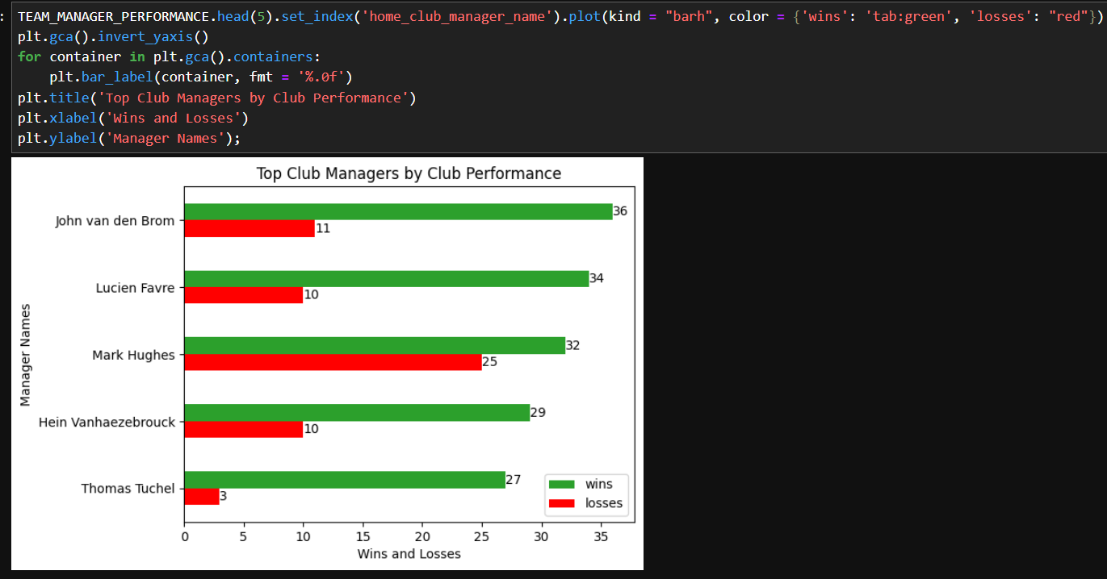
       3. Using Excel to further analyse the win-loss ratio
       4. INTERPRETATIONS:
          1. BEST MANAGERS IN TERMS OF WINS -> JOHN VAN DEN BROM -- 36 WINS AND 11 LOSSES, LUCIEN FAVRE -- 34 WINS AND 10 LOSSES, MARK HUGHES -- 32 WINS AND 25 LOSSES
          2. BEST MANAGERS IN TERMS OF WINS-LOSS RATIO -> THOMAS TUCHEL -- 9:1, LUCIEN FAVRE -- 3.4:1, JOHN VAN DEN BROM -- 3.3:1
    2. Which teams have the best win/loss ratio in various competitions?
       1. 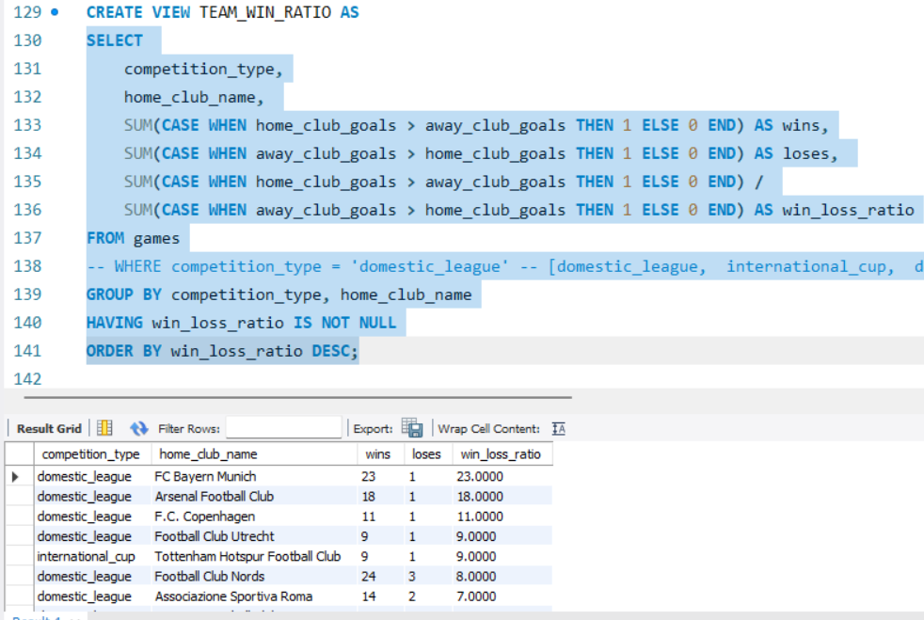
       2. 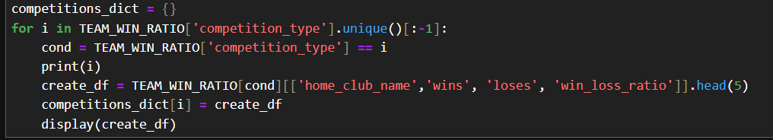  
          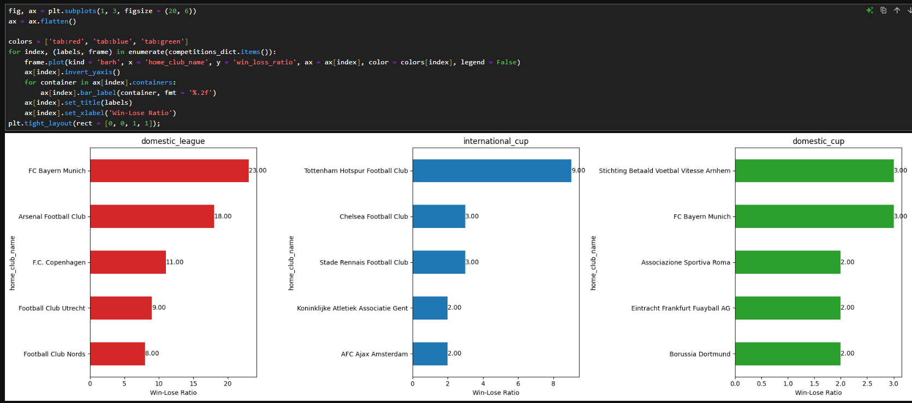
       3. Using Excel to make a interactive chart  
          
       4. INTERPRETATIONS:
          1. High Win-Loss ratio
          2. -- domestic_league
          3. FC Bayern Munich, 23 WINS, 1 LOSSES, 23 WIN LOSS RATIO, Arsenal Football Club, 18 WINS, 1 LOSSES, F.C. Copenhagen, 11 WINS, 1 LOSSES,
          4. -- international_cup
          5. Tottenham Hotspur Football Club, 9:1 win ratio, Chealsea Football Club, 3:1 win ratio, Stade Rennais Football Club, 3:1 win ratio
          6. -- domestic cup
          7. Stichting Betaald Voetbal Vitesse Arnhem, 3 wins,1 3:1, FC Bayern Munich, 3 wins, 1 loss, 3:1, Eintracht Frankfurt Fuayball AG, 4 wins, 2 losses, 2:1
    3. How does the position of the home and away clubs affect match outcomes?
       1. 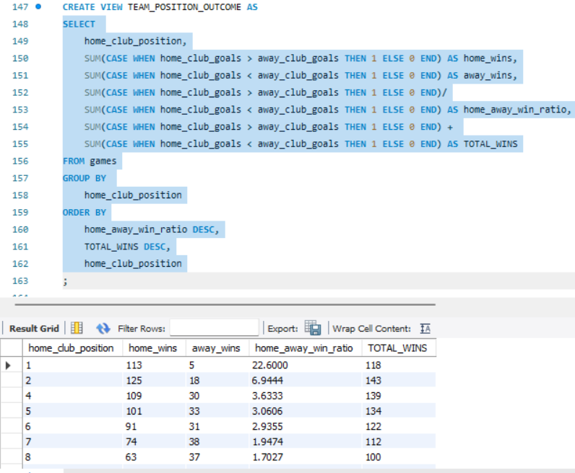
       2. 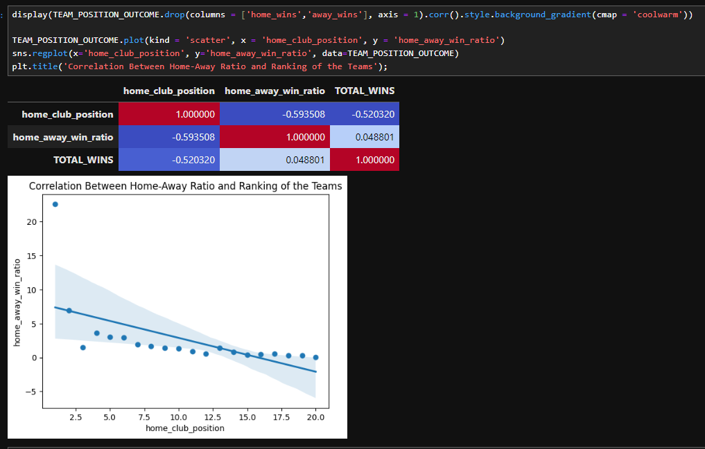
       3. INTERPRETATIONS:
          1. THE TEAMS AT HIGHER RANKINGS ARE SEEN TO HAVE HIGHER WINS LOSS RATIO
          2. HIGH NEGATIVE CORRELATION BETWEEN CLUB POSITION AND WIN-LOSS RATIO IS SEEN r = -0.59
          3. TEAMS NEED TO MAINTAIN THE WIN-LOSS RATIO TO RANK HIGHER
    4. How do teams’ performances vary across different seasons and competitions?
       1. Using Tableau Dashboard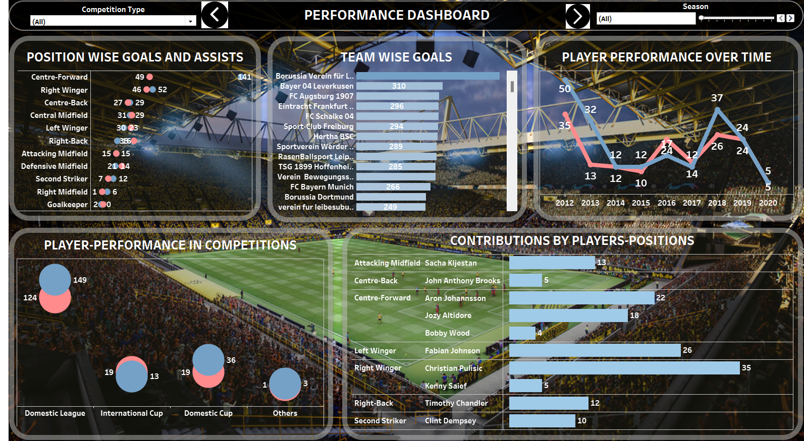
       2. INTERPRETATIONS:
          1. CENTER FORWARD HAS MOST GOALS AND ASSISTS OF 141 AND 49 RESPECTIVELY ACROSS ALL COMPETITIONS AND SEASONS
          2. BORRUSSIA HAS THE MOST NUMBER OF GOALS AT 541 ACROSS ALL COMPETITIONS AND SEASONS
          3. CONTRIBUTIONS TOWARDS GOALS AND ASSISTS IS 44 BY CENTRE FORWARD POSITIONED PLAYERS ACROSS ALL SEASONS AND COMPETITIONS
          4. PLAYERS HAVE 149 GOALS AND 124 ASSISTS ACROSS ALL SEASONS IN THE DOMESTIC LEAGUE COMPETITION TYPE WHICH IS THE HIGHEST ACROSS ALL COMPETITION TYPE
  1. ATTENDANCE AND STADIUM ANALYSIS
     1. Using MySQL connector thorough python to connect to MySQL database  
        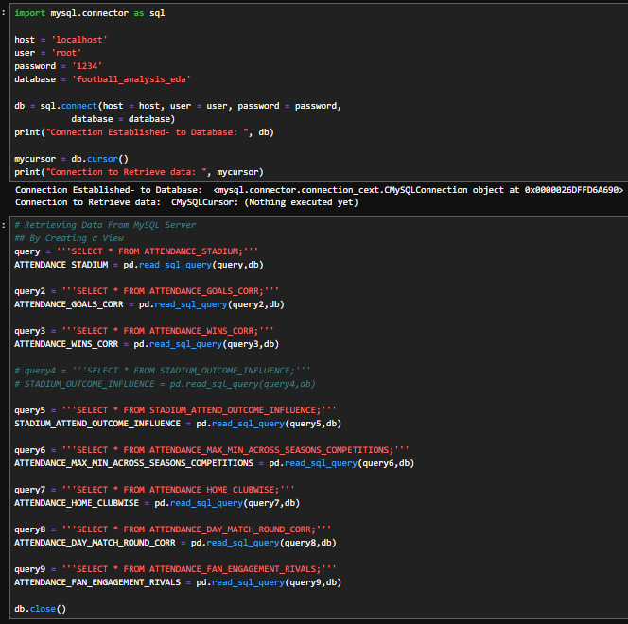
     2. What is the average attendance for matches at different stadiums?
     3. Which clubs tend to have the highest home attendance?
     4. What are Attendances across seasons or competitions?  
        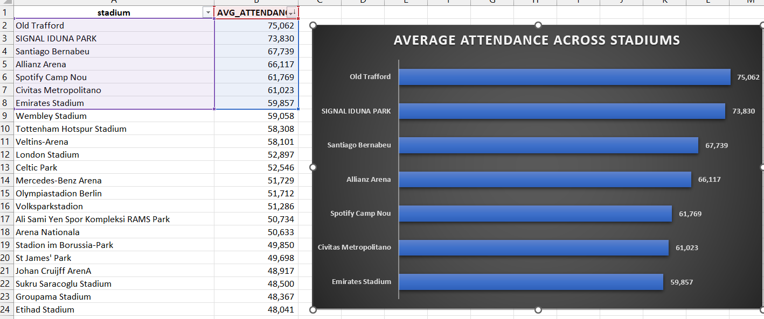  
        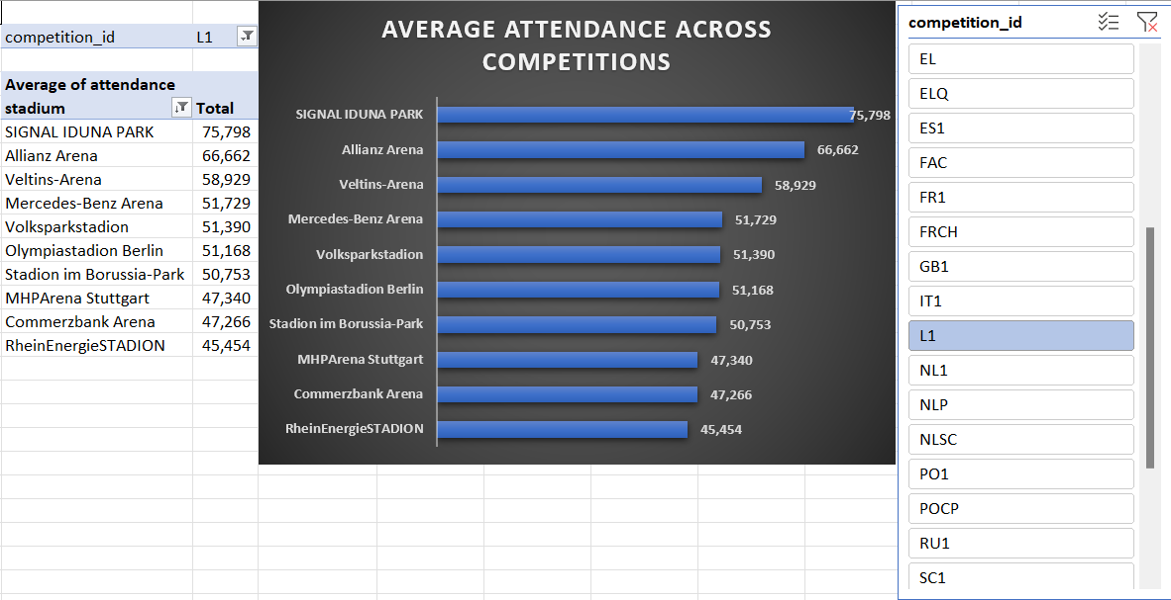
        1. INTERPRETATIONS:
           1. L1 COMPETITION LEAGUE HAS VERY HIGH AVERAGE ATTENDENCE ACROSS ALL COMPETITIONS
     5. Is there a correlation between attendance and team performance (goals, wins)?
     6. How do different stadiums influence our team's performance and fan turnout?
     7. Does higher attendance correlate with better home performance for our team?
        1. 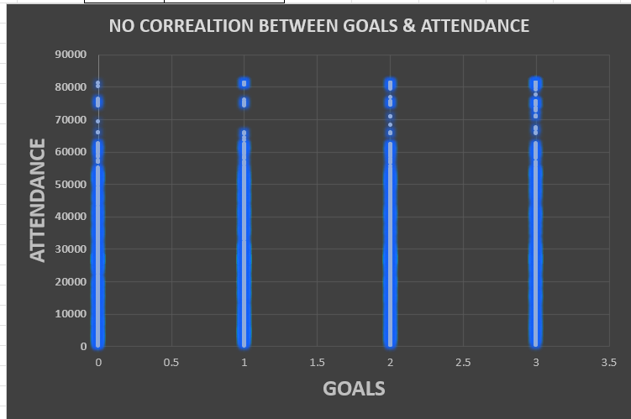
        2. 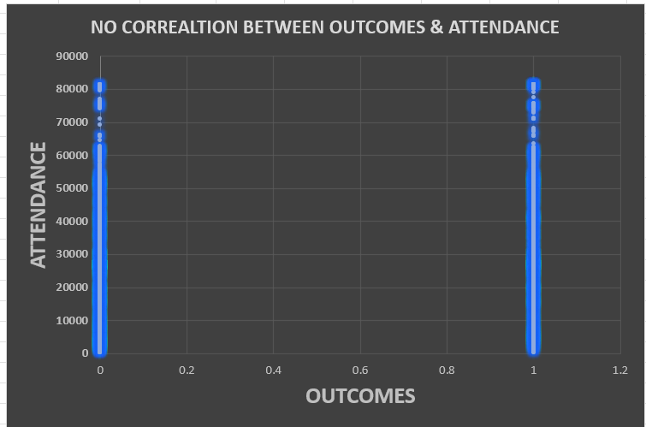
        3. INTERPRETATIONS:
           1. NO CORRELATIONS BETWEEN OUTCOMES, GOALS WITH ATTENDANCE
     8. How does stadium location influence match outcomes?
        1. Using Excel to find the stadiums having most wins percent and most loss percent for teams  
           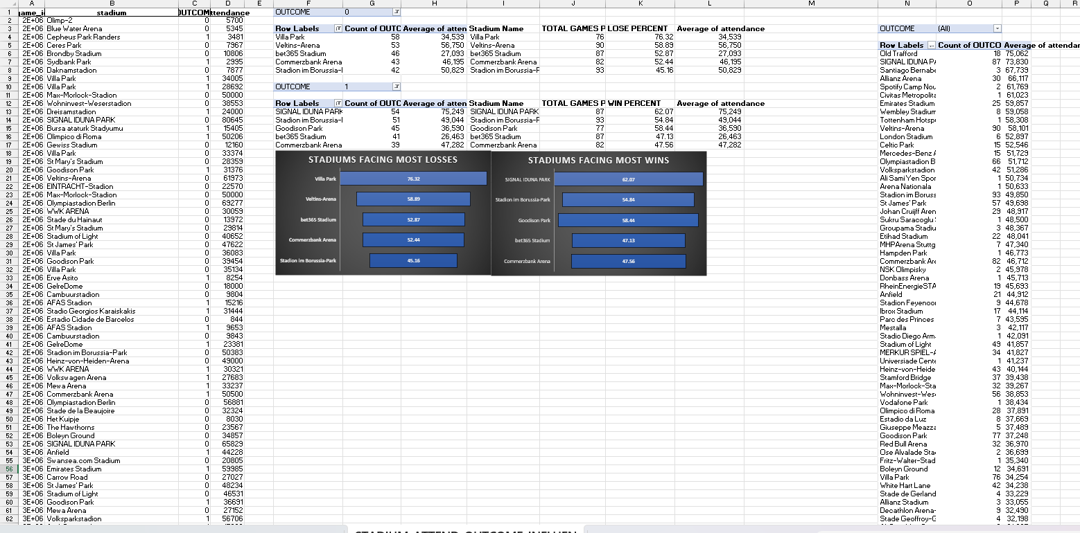
        2. INTERPRETATIONS:
           1. STADIUMS LIKE VILLA PARK, VELTINS ARENA, BET365 , COMMERZBANK ARENA, STADION IM BORUSSIA-PARK HAVE HIGH PERCENTAGE OF LOSING TEAMS OF OVER 50 %
           2. STADIUMS LIKE SIGNAL IDUNA PARK, GOODISON PARK, BET365 , COMMERZBANK ARENA, STADION IM BORUSSIA-PARK HAVE HIGH PERCENTAGE OF WINNING TEAMS OF OVER 60 %
     9. Attendance Patterns: Does day of the week and match round influence match attendance?
        1. Using MySQL, python and Excel to get the data  
           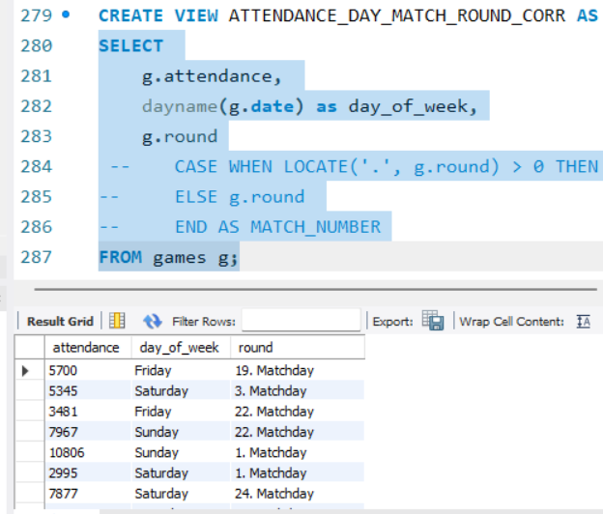  
           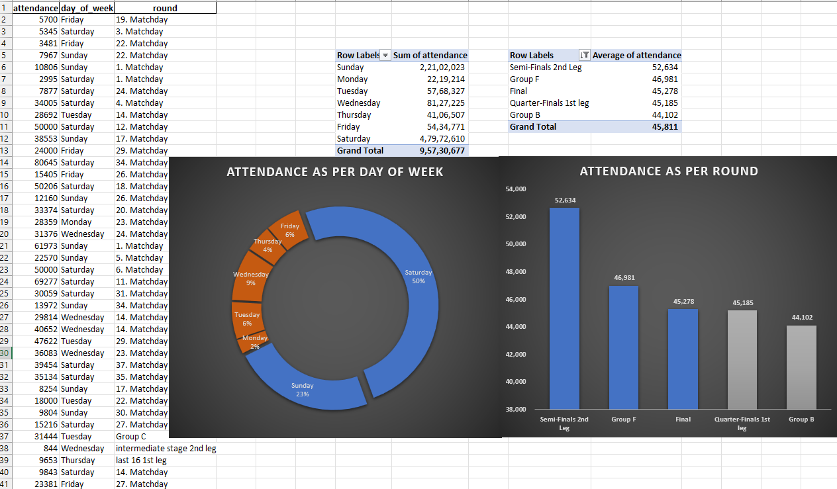
        2. INTERPRETATIONS:
           1. WEEKENDS HAVE AROUND 73 % ATTENDANCE AT STADIUMS
           2. ATTENDENCE TENDS TO BE APPROXIMATELY MORE THAN 40000 AT HIGH-PROFILE AND 2 LEGGED MATCHES
     10. Fan Engagement: Which matches (competitions, rivals) bring in the most fans, and how can we capitalize on this through promotions?
         1. Using MySQL, Python and Excel   
            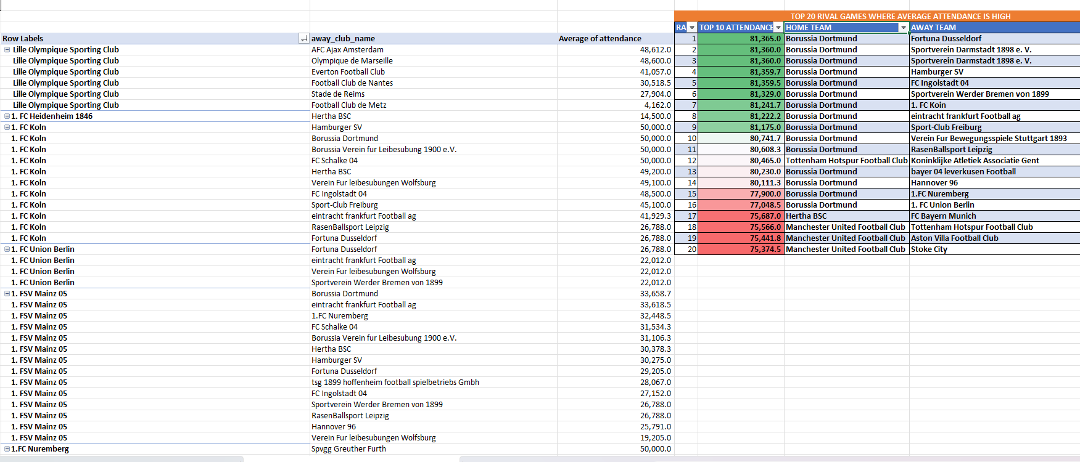
         2. INTERPRETATIONS:
            1. BORUSSIA DORTMUND AND MANCHESTER UNITED FOOTBALL CLUB HAVE AN AUDIENCE OF MORE THAN 75,000 ATTENDANCE
            2. WHILE BORUSSIA DORTMUND HAS REACHED MORE THAN 80,000 ATTENDANCE
     11. USING KNN CLASSIFICATION  
         Can we classify stadiums based on historical attendance patterns?  
         Features: stadium, attendance.
         1. Checking the attendance distribution  
            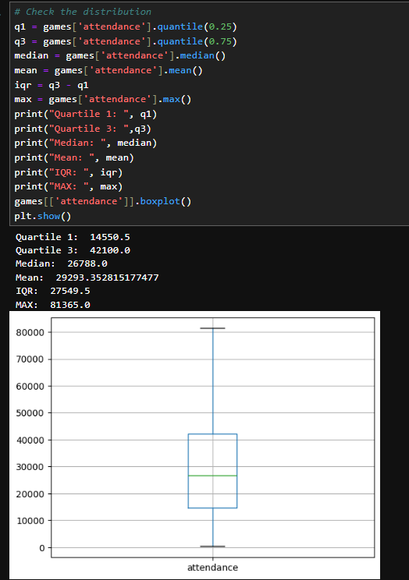
         2. Preparing the data for model by label encoding categorical columns and scaling numerical columns  
            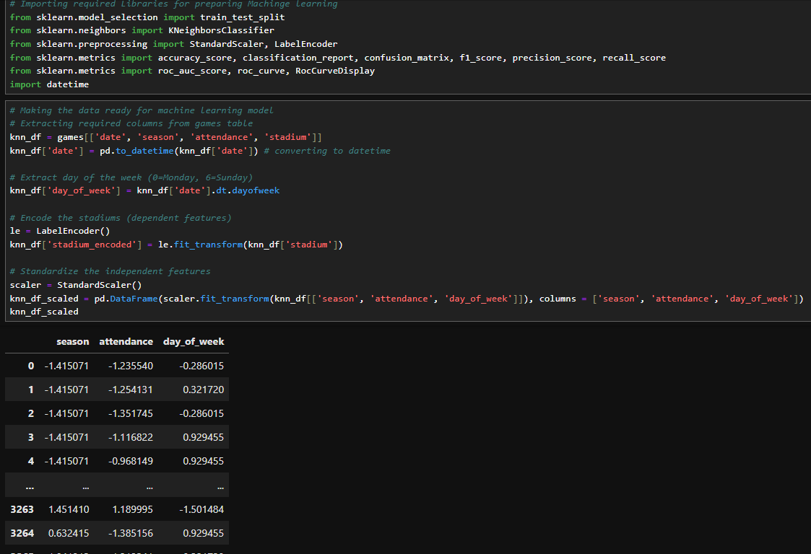
         3. Check for correlation and find that attendance has higher correlation to stadiums  
            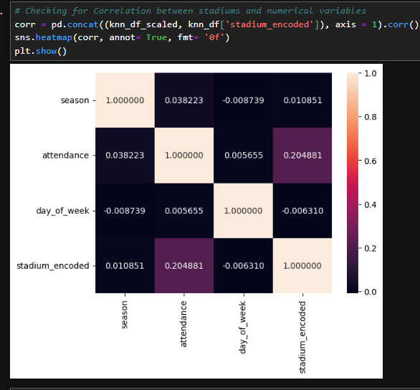
         4. Train the data on attendance and market value train dataset and find the k-nearest neighbour value where the error rate (difference between actual value and predicted value) is lowest by visualizing elbow curve  
            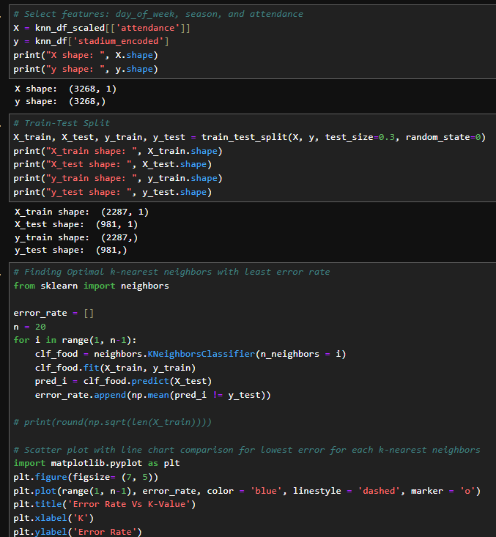
         5. Find the lowest point of error assuming 15 neighbors  
            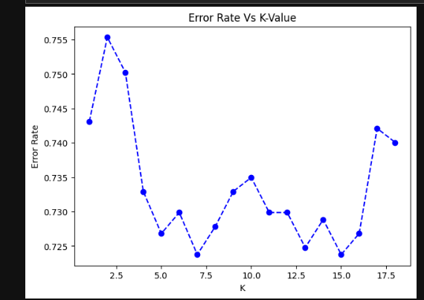
         6. Find the stadiums where the model is able to predict above 70 % f1score(harmonic mean of precision and recall)  
            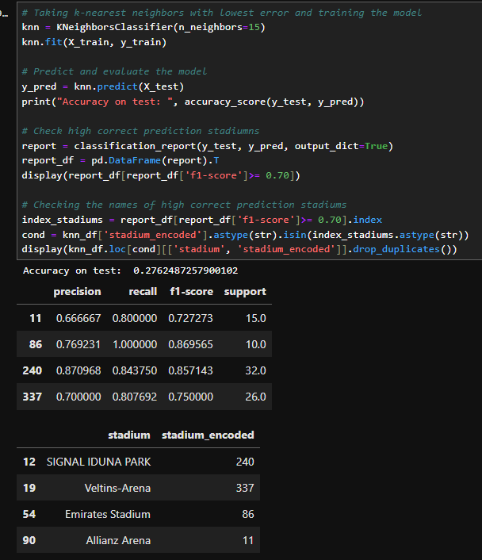
         7. INTERPRETATIONS:
            1. THE KNN MODEL DOES NOT WORK WELL ON ENTIRE DATASET HAVING 27% ACCURACY
            2. BUT IT CAN PREDICT SIGNAL IDUNA PARK, VELTINS-ARENA, EMIRATES STADIUMS, ALLIANZ ARENA WITH MORE THAN 70 % F1 SCORE
  2. REFEREE ANALYSIS
     1. Using Tableau to visualize charts
     2. How do different referees impact the number of yellow/red cards in matches?
     3. What is the average number of cards and fouls issued by different referees in our matches?
        1. Using Horizontal Stacked Bar Charts  
           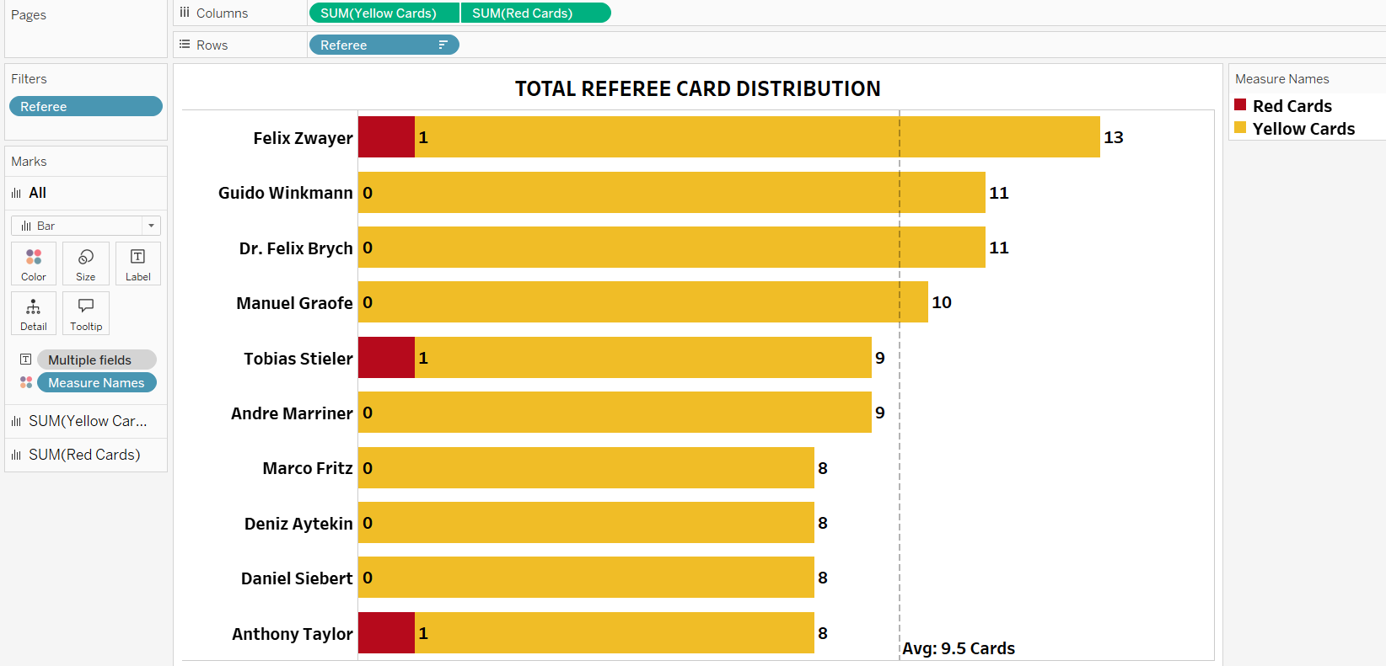
        2. INTERPRETATIONS:
           1. FELIX ZWAYER (13 YELLOW AND 1 RED CARD), GUIDO WINKMANN (11 YELLOW CARDS), DR. FELIX BRYCH (11 YELLOW CARDS)
           2. THIS SHOWS THE STRICTNESS OF THE REFERREE
     4. Which referees tend to officiate high-profile matches (e.g., finals)?
        1. Using Horizontal Bar Chart to represent Number of times referee officiated the matches  
           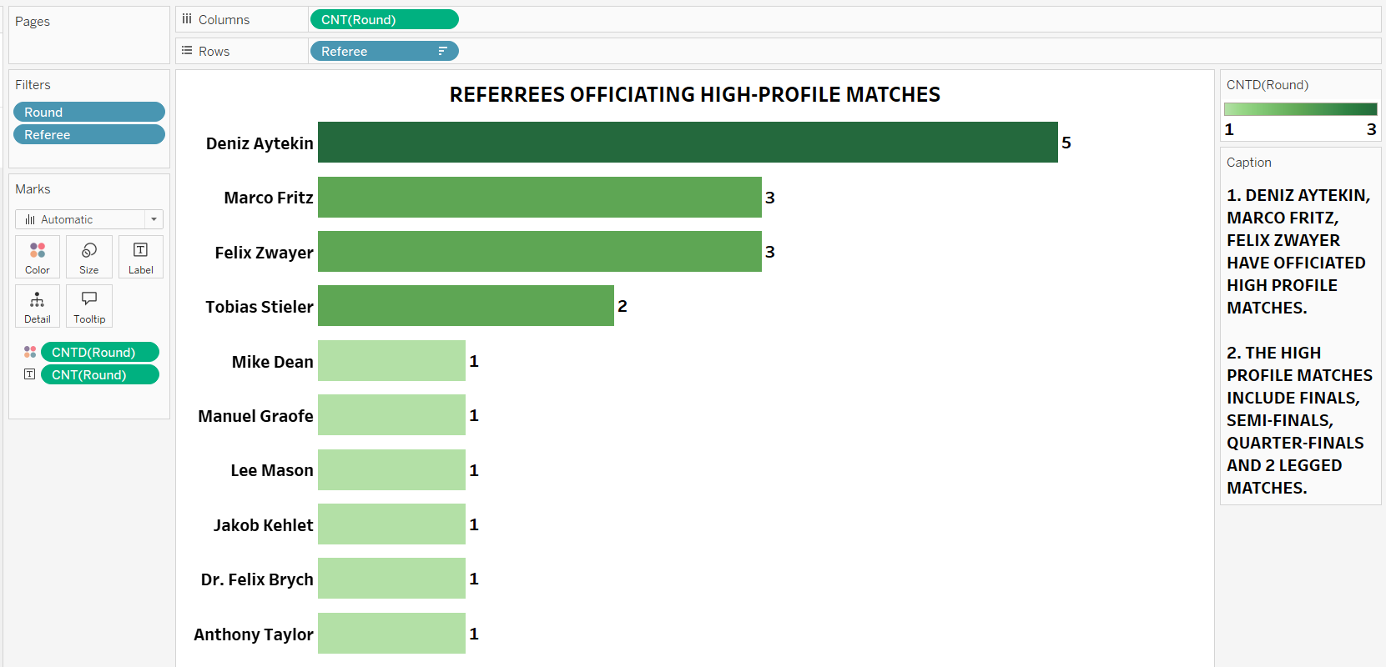
        2. INTERPRETATIONS:
           1. DENIZ AYTEKIN (5), MARCO FRITZ(3), FELIX ZWAYER (3)HAVE OFFICIATED HIGH PROFILE MATCHES.
           2. THE HIGH-PROFILE MATCHES INCLUDE FINALS, SEMI-FINALS, QUARTER-FINALS AND 2 LEGGED MATCHES.
     5. Are certain referees associated with higher or lower goal counts?
     6. How does referee assignment affect home or away team performance?
        1. Using Side-By-Side Horizontal Bar Charts to represent average goals scored, average home goals scored and average away goals scored  
           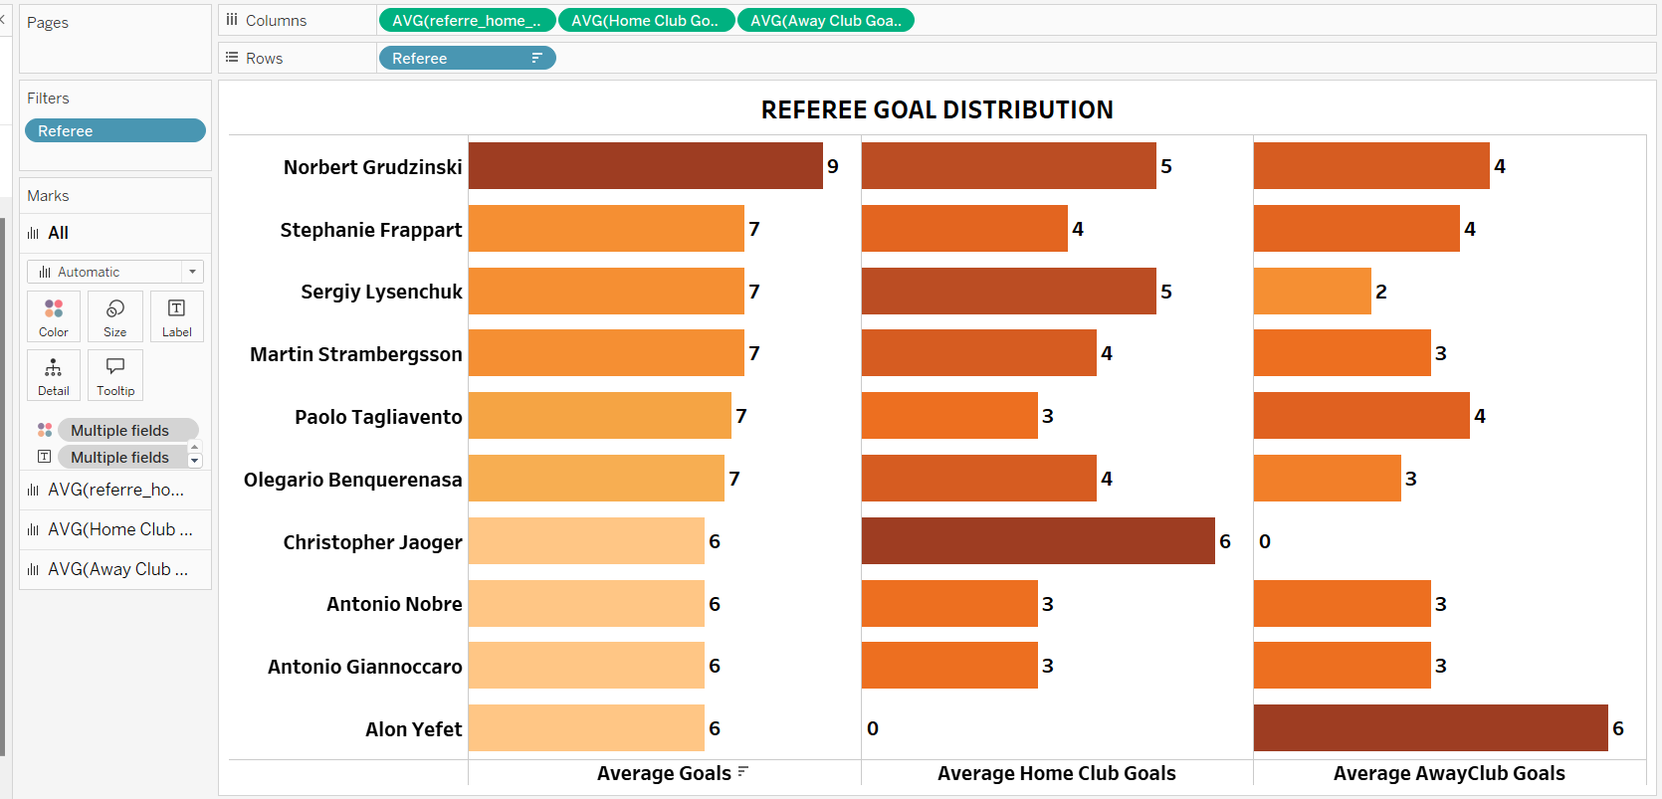
        2. INTERPRETATIONS:
           1. REFERREES LIKE CHRISTOPHER JAOGER HAVE AVERAGE 6 GOALS SCORED BY HOME CLUBS AND ALON YEFET HAVE AVERAGE GOALS SCORED BY AWAY CLUBS. BOTH HAVING AVERAGE OF HOME AND AWAY CLUBS SCORED AS 6.
           2. REFERREES LIKE NORBERT GRUDZINSKI AND STEPHANIE FRAPPART HAVE ALMOST EQUAL BUT HIGH NUMBER OF GOALS SCORED BY BOTH HOME AND AWAY CLUBS.
           3. NORBERT HAVING 9 AVERAGE GOALS, 5 AVG HOME CLUBS GOALS, 4 AWAY CLUB GOALS AND STEPHANIE HAVING 7 AVERAGE GOALS, 4 AVG HOME CLUB GOALS AND 4 AVG AWAY CLUB GOALS
  3. SUBSTITUTION ANALYSIS  
     Using Tableau Charts
     1. Which players come off the bench and contribute to goals/assists?
        1. Using Heatmap chart to show the players who are substituted at certain minutes of the games and the goals scored by them at that minute  
           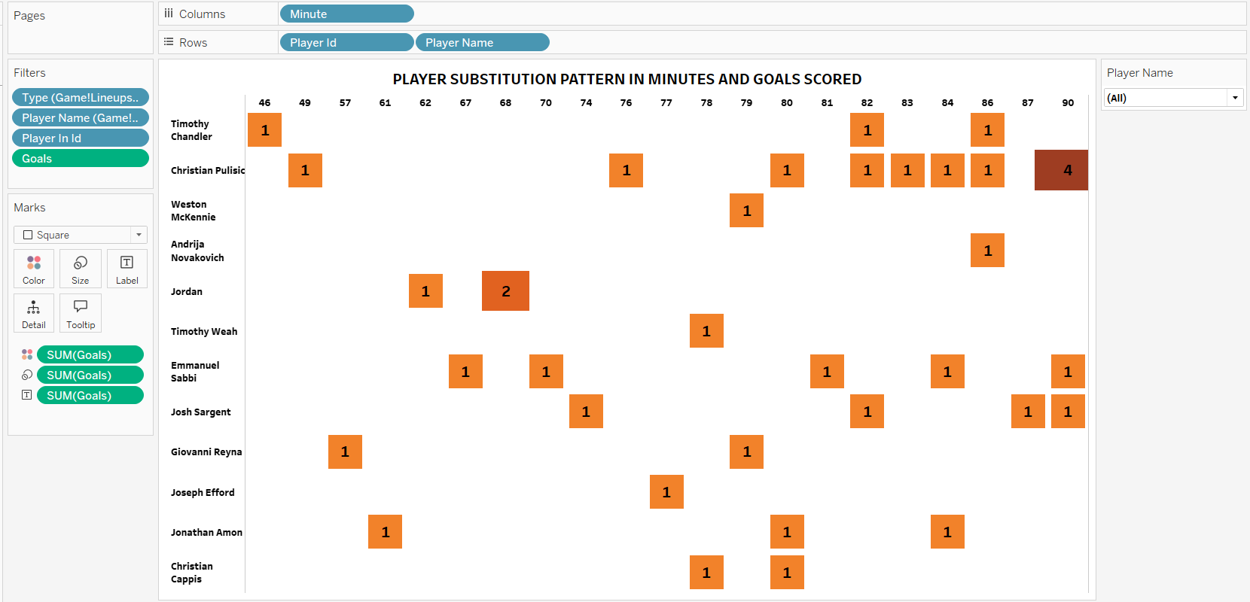
        2. INTERPRETATIONS:
           1. THE CHART SHOWS PLAYERS SUBSTITUTION MINUTE WISE IN THE GAMES AND THE GOALS TOTAL GOALS SCORED BY THE SAME PLAYERS
           2. CHRISTIAN PULISIC TIMOTHY CHANDLER JOSH SARGENT ARE SUBSTITUTED MANY TIMES ACROSS THE GAMES DESPITE THEIR GOALS PERFORMANCE
           3. CHRISTIAN PULISIC HAS SCORED 4 GOALS ON SOME OCCASSIONS AND HAS BEEN SUBSTITUTED AT 90TH MINUTES OF THE GAME
     2. Are certain players regularly substituted, and how does it affect their performance?
        1. Using Tableaus’ Horizontal Bar Chart to depict the number of times the players have been substituted  
           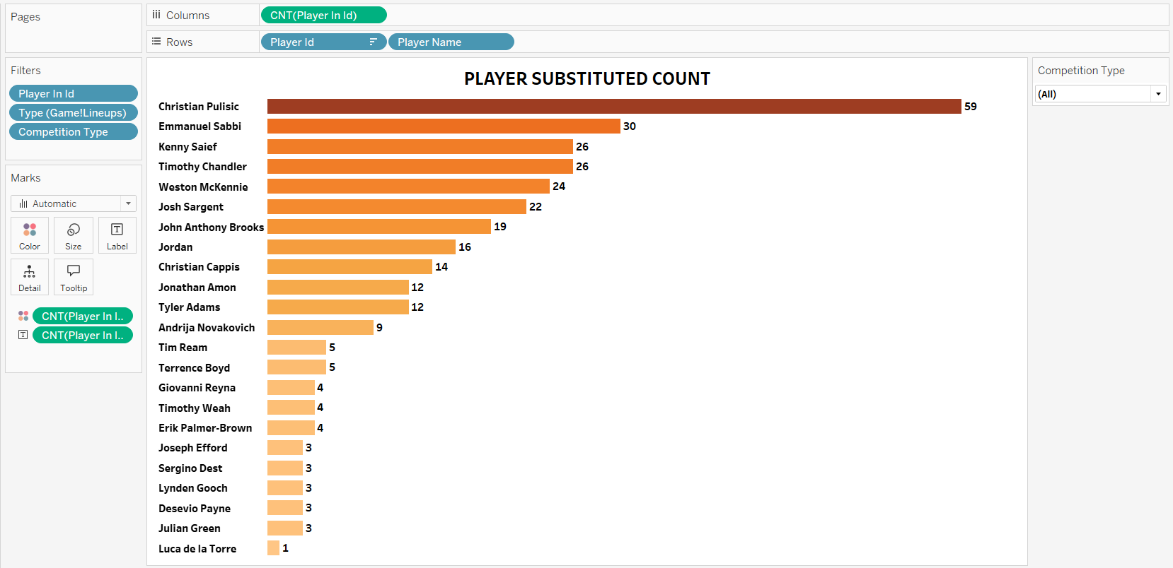
        2. INTERPRETATIONS:
           1. CHRISTIAN PULISIC, EMMANUEL SABBI AND KENNY SAIEF HAVE BEEN SUBSTITUTED 59, 30, 26, TIMES RESPECTIVELY
           2. ALTHOUGH ALL 3 ARE TOP PERFORMERS IN TERMS OF GOALS AND ASSISTS, REASON FOR SUBSTITUTION SHOULD BE CHECKED
     3. How do teams’ substitution patterns vary ?
        1. Using Tableau Horizontal Bar Chart to depict Number of Substitutions Done by each team  
           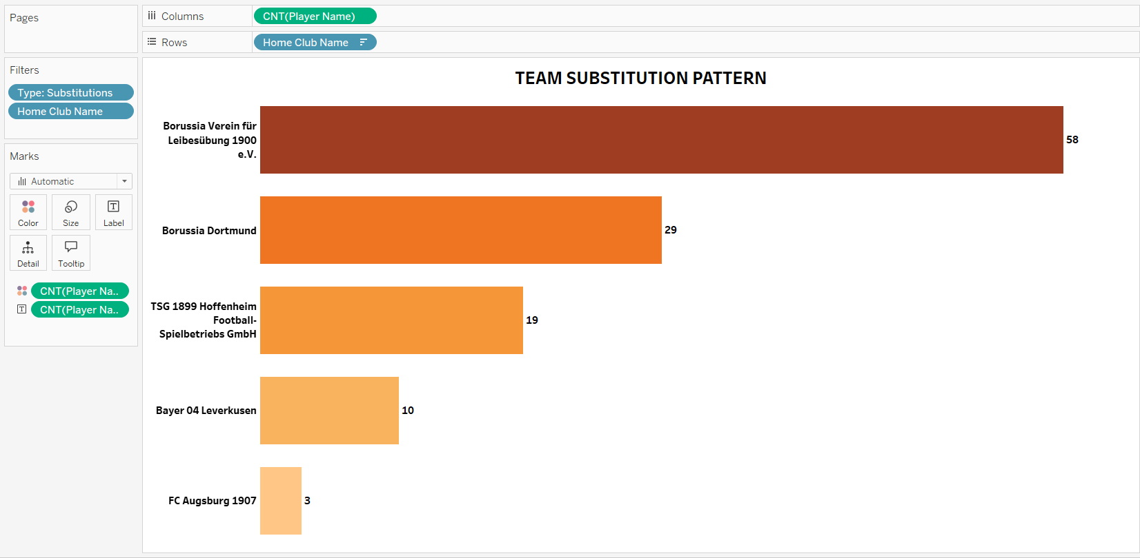
        2. INTERPRETATIONS:
           1. BORUSSIA VEREIN FÜR LEIBESÜBUNG 1900 E.V. AND BORUSSIA DORTMUND ARE THE TEAMS HAVING MOST SUBSTITUTIONS OF 58 AND 29 TIMES
     4. Which positions are most frequently substituted ?
        1. Using Tableau Horizontal Bar Chart to represent sub-position wise substitution pattern   
           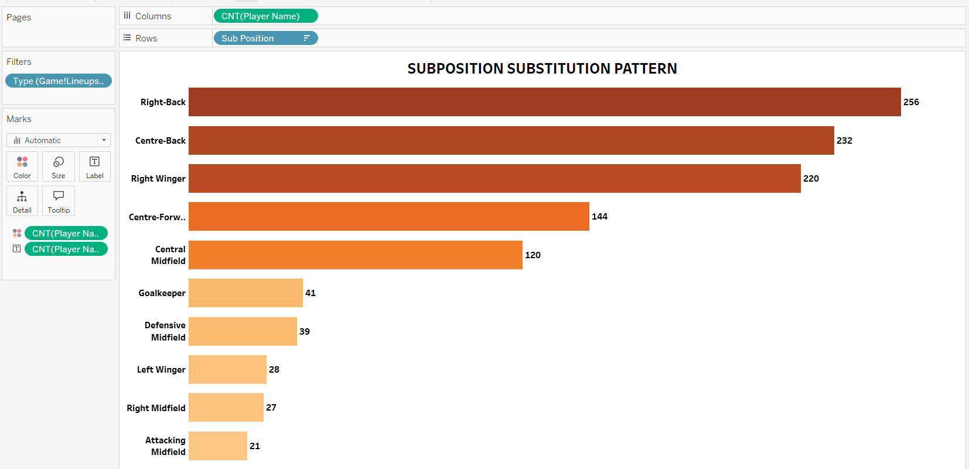
        2. INTERPRETATIONS:
           1. RIGHT BACK, RIGHT WINGER AND CENTRE BACK POSITIONS HAVE BEEN MOSTLY SUBSTITUTED 256 AND 232 TIMES RESPECTIVELY
           2. RIGHT MIDFIELD AND ATTACKING MIDFIELD HAVE BEEN LEAST SUBSTITUTED 27 AND 21 TIMES RESPECTIVELY
  4. EVENT ANALYSIS
     1. Using MySQL and Excel Directly to get the data into excel and analyse data in Excel through OBDC connector.  
        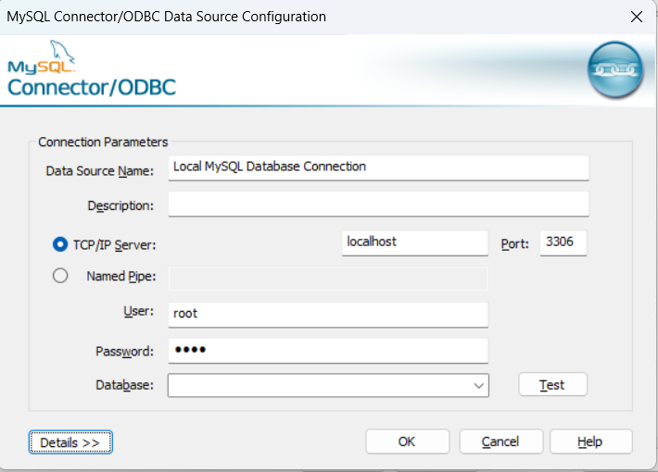
     2. Establish connection  
        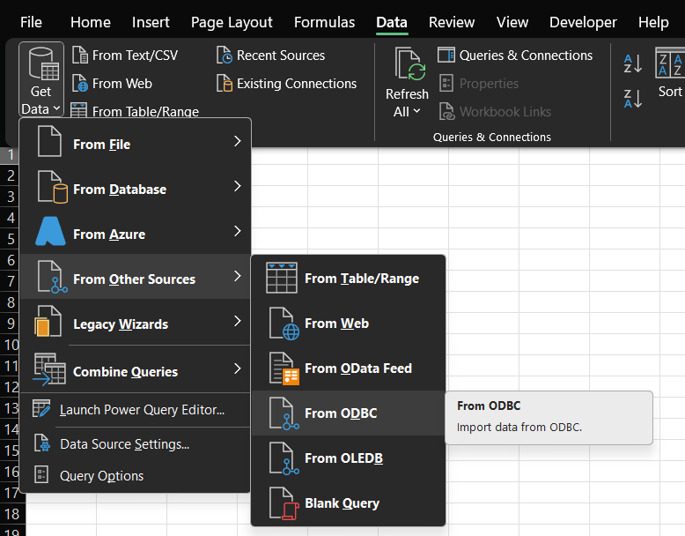
     3. Select the required tables from MySQL Server
     4. Merge Tables using Power Query   
        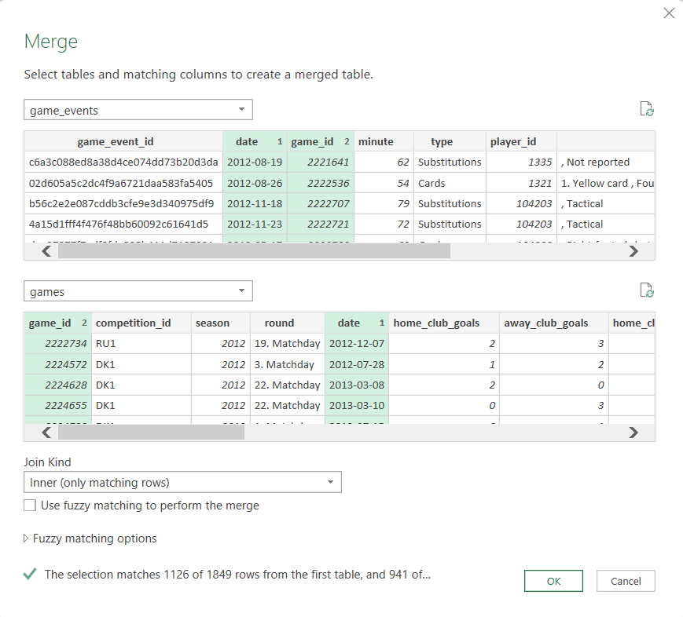
     5. Select all the columns in the game table and close and load  
        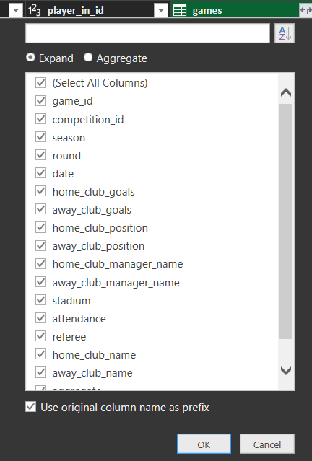
     6. Add a new column to find game won or lost by home team 1 for win and 0 for lost  
        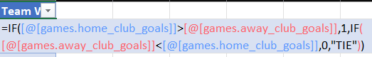
        1. What are the most common events recorded (goals, yellow cards, red cards)?
           1. Using Pivot Table – Most Common Events  
              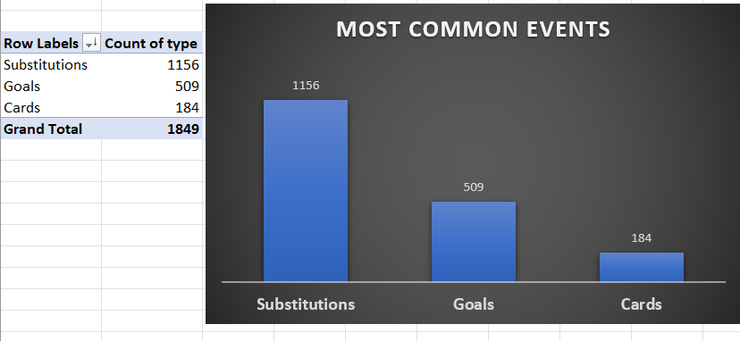
        2. How do events like goals, fouls, or cards influence the final score?
           1. Using Pivot Table – EVENT OUTCOME RELATION  
              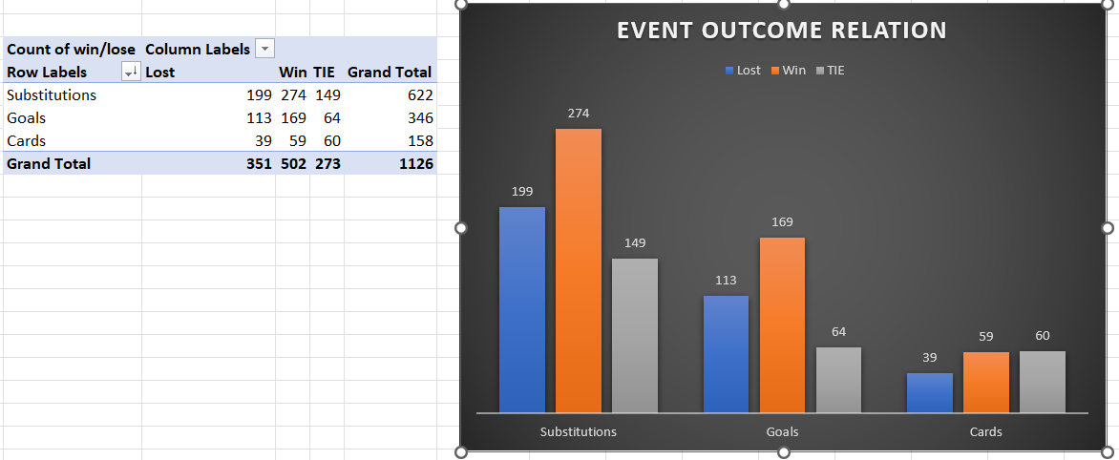
        3. How do goals scored before halftime affect the team’s chances of winning?
           1. Using Pivot Table prior to and after halftime – To Find the Probability of Winning out of games played  
              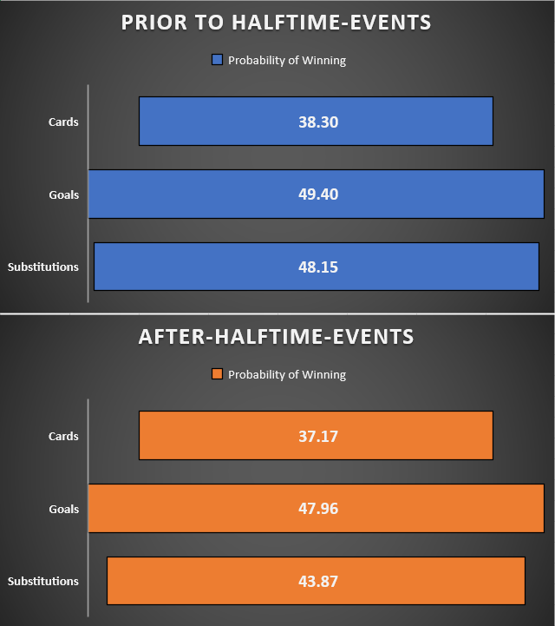
        4. What minute of the game sees the most significant events (e.g., goals, substitutions)?
           1. Using Pivot Table and Group Option to group bins for minutes for each event type  
              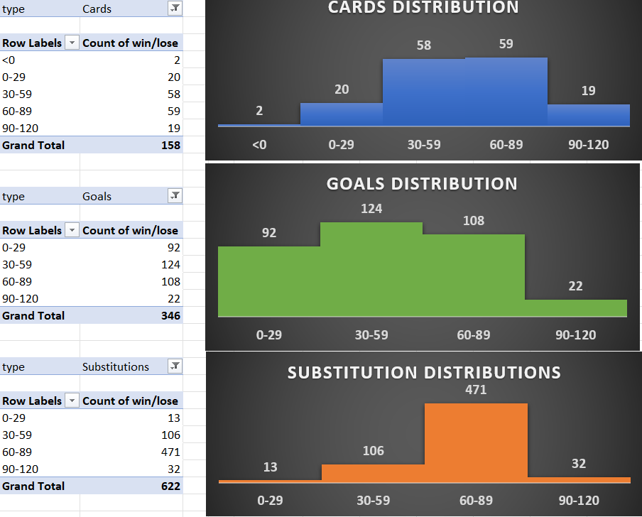
        5. Hypothesis Testing: Goals Scored in the Last 15 Minutes of a Game Are More Likely to Impact the Final Result (Win/Loss)
           1. Using Python to perform Hypothesis Testing  
              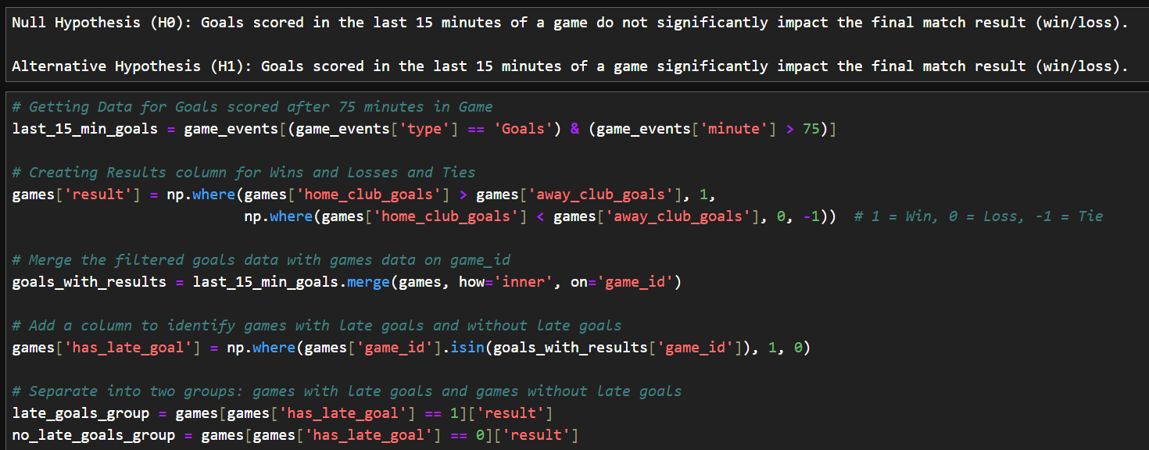   
              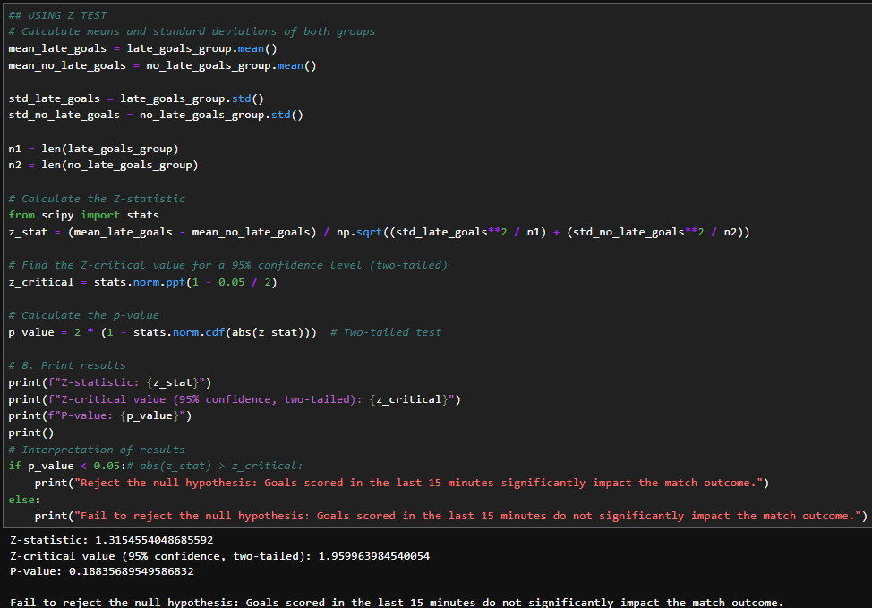
           2. INTERPRETATIONS:

WITH 95 % CONFIDENCE WE CAN INFER THAT THE GOALS SCORED IN THE LAST 15 MINUTES DO NOT SIGNIFICANTLY IMPACT MATCH OUTCOMES

Z-TEST IS USED HERE SINCE POPULATION STANDARD DEVIATION IS KNOWN AND SAMPLE SIZE IS GREATER THAN 30

* 1. COMPETITION ANALYSIS
     1. Using Tableau Dashboard to answer questions  
        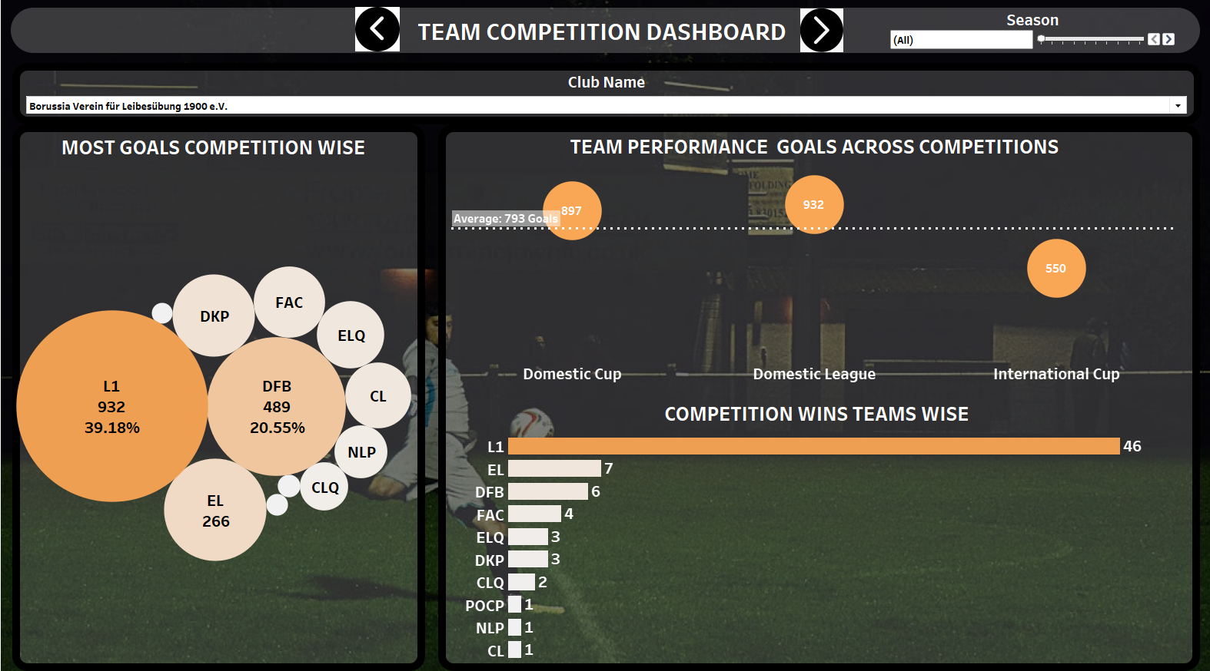
        1. How does a team's performance vary between different competitions?
        2. Are there specific teams that excel in one competition over others?
           1. INTERPRETATIONS:

BORRUSSIA VEREIN HAS THE BEST PERFORMANCE AMONGST ALL TEAMS WITH MOST NUMBER OF WINS OF 74 HAVING AVERAGE GOALS OF APRROXIMATELY 800 GOALS ACROSS SEASONS AND COMPETITIONS

* + - 1. Which competitions are the most competitive in terms of goals scored ?
      2. How do team performance differ across competitions?
      3. Which teams have the best record in specific competitions?
         1. INTERPRETATIONS:

BORRUSSIA VEREIN HAS THE BEST PERFORMANCE AMONGST ALL TEAMS HAVING 932 WINS IN L1 COMPETITIONS

* + - 1. How does our team’s performance vary across different competitions (e.g., domestic league, international tournaments)?
         1. INTERPRETATIONS:

BORRUSSIA VEREIN HAS THE BEST PERFORMANCE IN THE DOMESTIC LEAGUE WITH 932 GOALS

* 1. PLAYER ATTRIBUTES AND DEMOGRAPHICS ANALYSIS
     1. How do player attributes (height, foot, position) correlate with performance metrics (goals, assists)?
        1. Using Python to merge the players and appearance tables to get the average goals and assists for height, foot, position  
           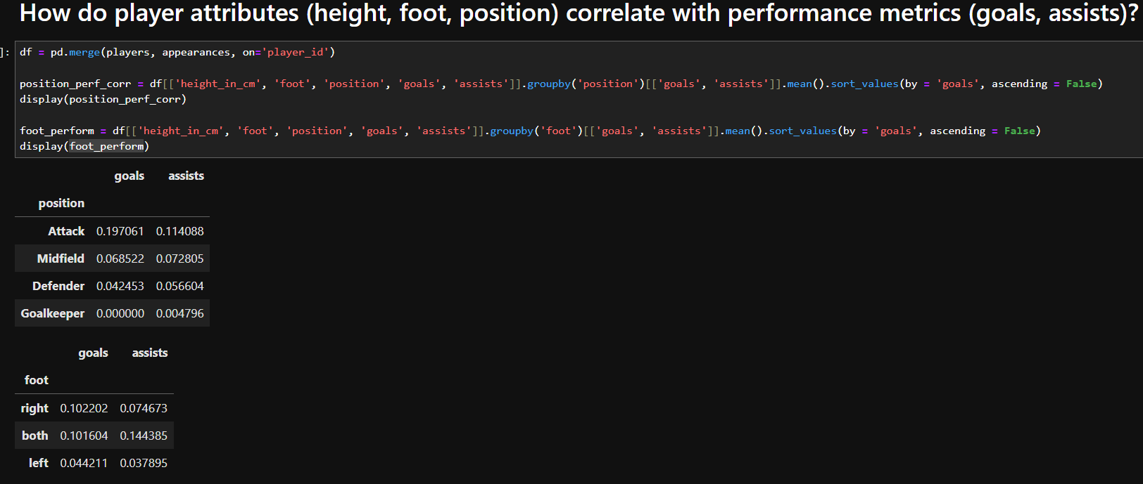  
           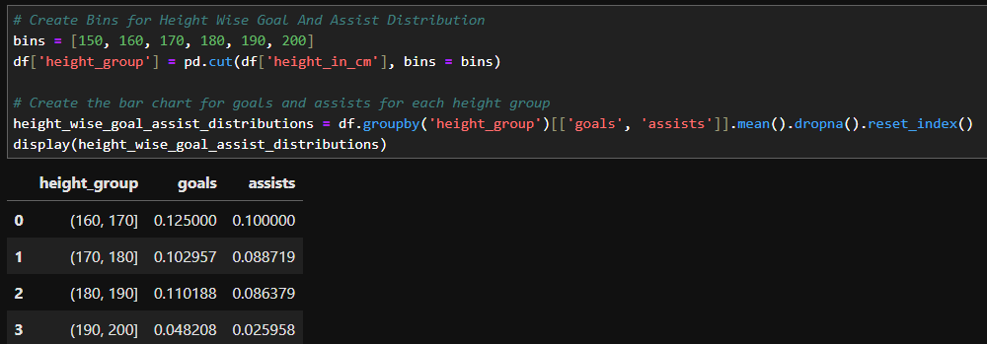
        2. Using Excel Column Chart to visualize these in excel
        3. INTERPRETATIONS:
           1. PLAYERS WITH HEIGHTS BETWEEN 160 – 170 CM SCORE 0.13 GOALS AND 0.10 ASSISTS WHICH IS MORE THAN ANY OTHER HEIGHT GROUPS
           2. HEIGHT GROUP 170 – 180 SCORES 0.1 GOALS AND 0.09 ASSISTS
           3. HEIGHT GROUP 180 – 190 SCORES 0.11 GOALS AND 0.09 ASSISTS
           4. HEIGHT GROUP 190 – 200 SCORES 0.05 GOALS AND 0.03 ASSISTS
           5. PLAYERS WITH BOTH DOMINANT FOOT SCORE 0.14 GOALS AND 0.10 ASSISTS WHICH IS MORE THAN PLAYERS HAVING ONLY RIGHT OR ONLY LEFT DOMINANT FOOT
           6. RIGHT FOOT DOMINANT PLAYERS SCORES 0.1 GOALS AND 0.07 ASSISTS
           7. LEFT FOOT DOMINANT PLAYERS SCORES 0.04 GOALS AND 0.04 ASSISTS
           8. PLAYERS PLAYING AT ATTACK POSITION SCORE 0.20 GOALS AND 0.11 ASSISTS WHICH IS MORE THAN ANY OTHER POSITION PLAYERS
           9. MIDFIELD PLAYERS SCORES 0.07 GOALS AND 0.07 ASSISTS
           10. DEFENDER PLAYERS SCORES 0.04 GOALS AND 0.05 ASSISTS
     2. What is the age distribution of players, and how does age affect performance?
        1. Using Python to merge players and appearances on player_id and get the details average goals and assists scored by age groups  
           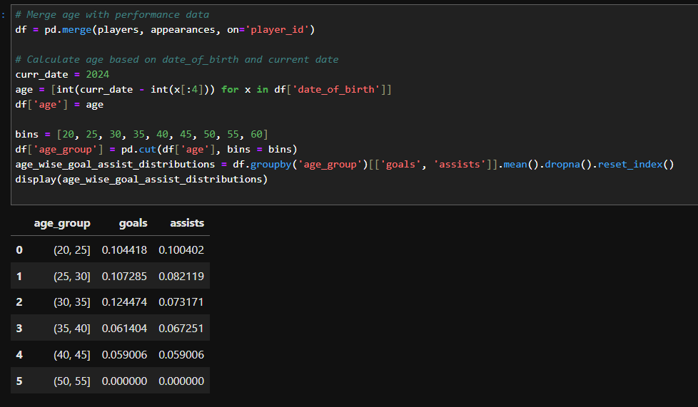
        2. Using Excel to visualize the Column Chart
        3. INTERPRETATIONS:
           1. PLAYERS IN AGE GROUP 30 TO 35 HAVE THE MOST AVERAGE GOALS OF 0.12
           2. PLAYERS IN AGE GROUP 20 – 25 HAVE THE MOST ASSISTS OF 0.10
           3. THERE IS A CERTAIN TREND SEEN, AVERAGE GOALS TEND TO INCREASE FROM AGE GROUP 20 – 25 FROM 0.10 TO 0.11 IN 25 – 30 AND TO 0.12 IN AGE 30 – 35 AND THEN BEGINS TO DECREASE IN THE LATER AGES
           4. AVERAGE ASSISTS TEND TO ONLY DECREASES AS THE AGE GROUP INCREASES. FROM 0.10 IN 20-25 , 0.08 IN 25 – 30, 0.07 IN 30 – 35 , 0.07 IN 35 – 40 TO 0.06 IN 45 – 50 AGE GROUPS
     3. Are players from certain countries more successful in specific competitions?
        1. Using Python to get data for each competition   
           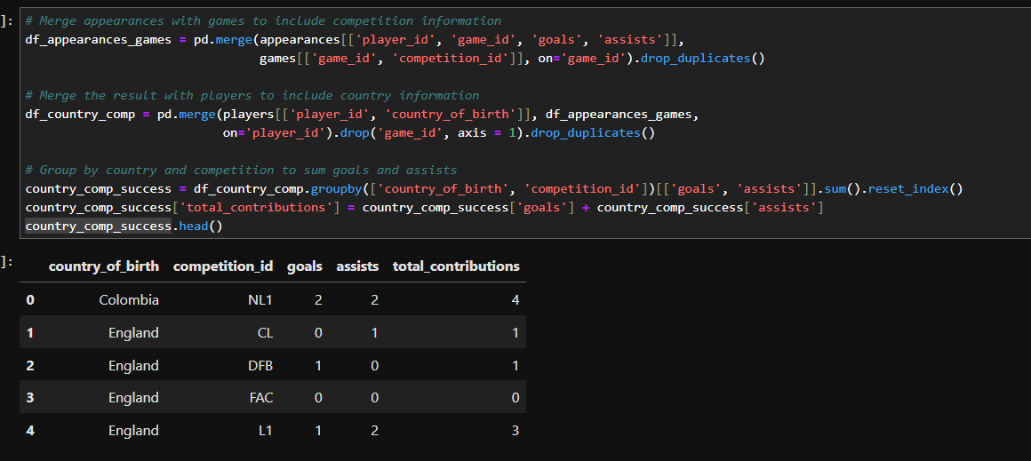
        2. Using Excel to visualise
        3. INTERPRETATIONS:
           1. UNITED STATES HAS 79 % CONTRIBUTION TO TOTAL CONTRIBUTIONS THROUGH GOALS AND ASSISTS WHICH IS THE HIGHEST AMONG THE NATIONS
     4. Which sub-positions contribute the most to team success (goals, assists)?
        1. Using Python to merge and get position and sub position wise goals and assists  
           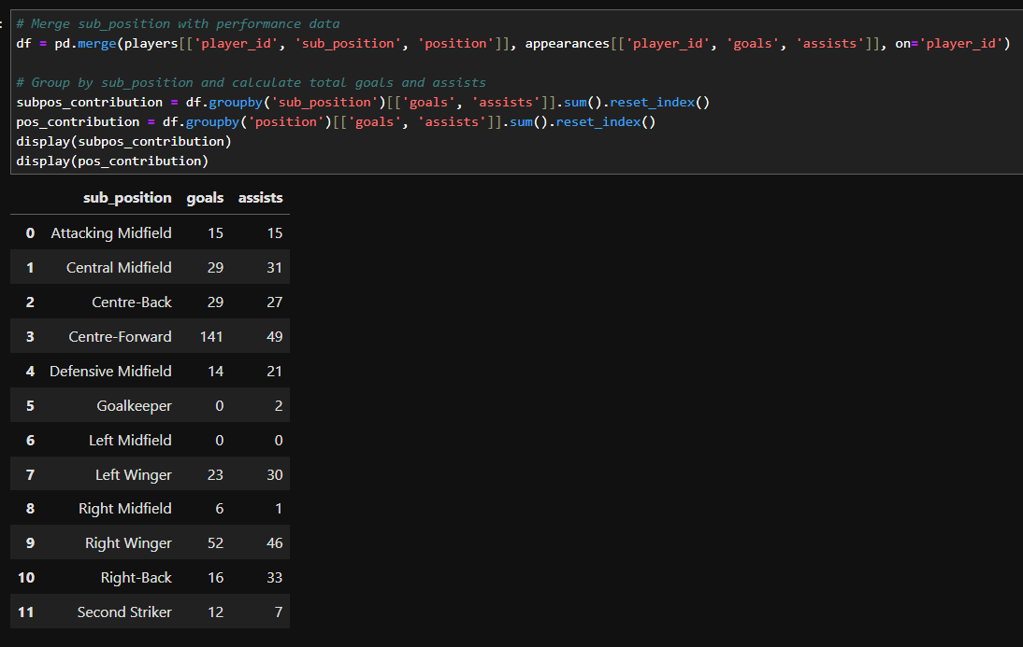  
           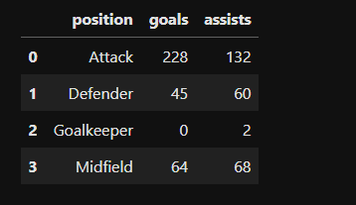
        2. Using Excel to Visualize the same in form of horizontal bar graphs
        3. INTERPRETATIONS:
           1. CENTRE FORWARDS HAVE THE MOST NUMBER OF GOALS AND ASSISTS OF 141 AND 49 RESPECTIVELY
           2. RIGHT WINGERS ARE 2ND WITH 52 GOALS AND 46 ASSISTS
           3. ATTACKERS ARE SEEN WITH MORE GOALS (228)THAN ASSISTS (132) WHILE DEFENDERS ARE SEEN WITH MORE ASSISTS (60)THAN GOALS (45) AND MIDFIELD WITH BALANCED GOALS (64)AND ASSISTS(68)
     5. USING K-MEANS CLUSTERING  
        Can we group players by their market value, physical attributes, and demographics to explore potential investment opportunities?
        1. Using Python to create age column, encode country, scaler numerical columns  
           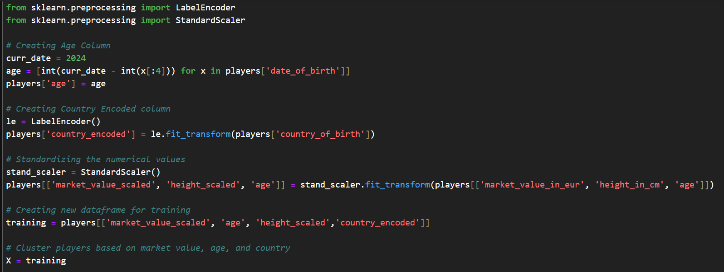
        2. Find the optimal value of k where WCSS (Within Cluster Sum of Square) rate of decrease is the maximum   
           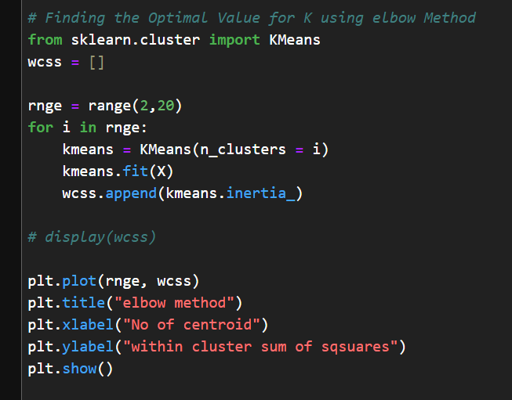
        3. By plotting elbow curve of WCSS shows the optimum value is between 11 – 12.5 (assuming 12)  
           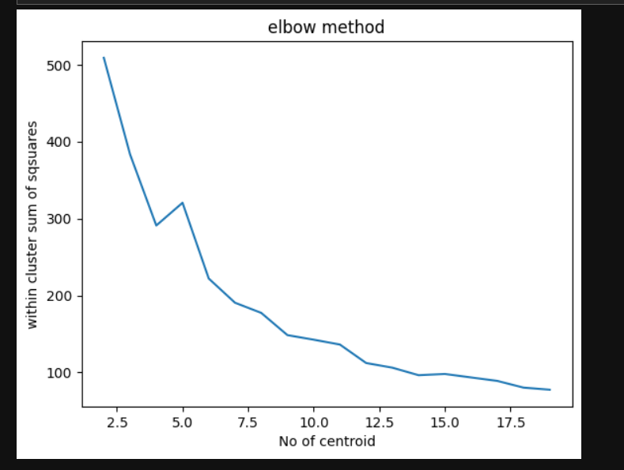
        4. Plotting a 3 d scatter plot using ChatGPT Ai to plot atleast 3 dimensions  
           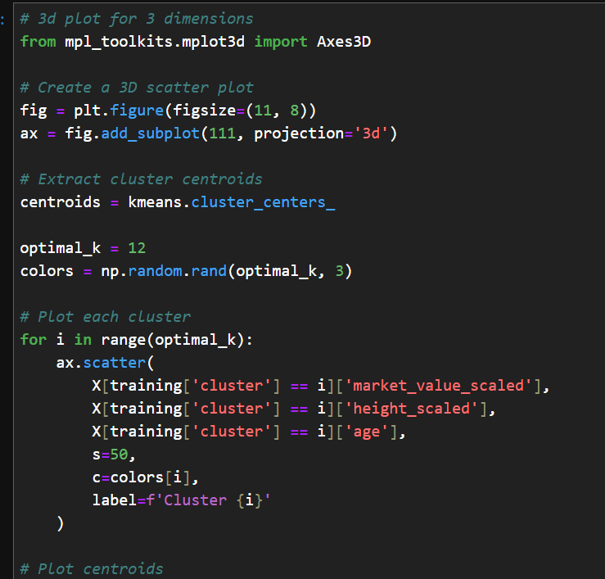  
           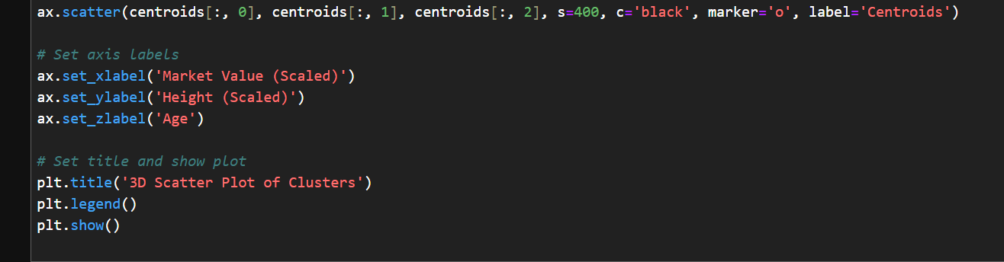  
           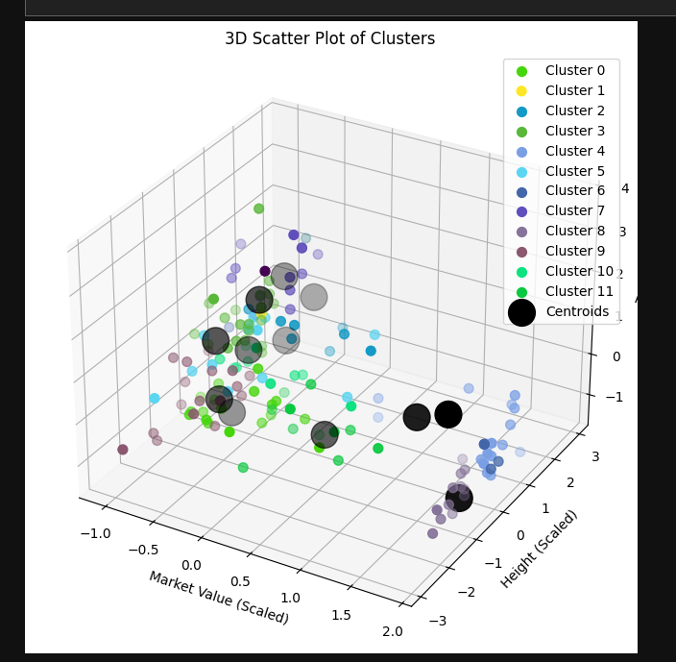
        5. Using Silhouette Score method to evaluate the model  
           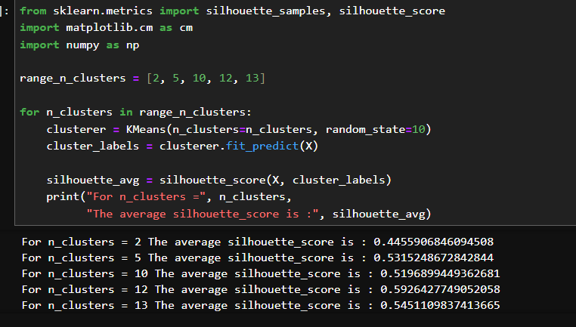
        6. INTERPRETATIONS:
           1. AT K = 12 THE RATE OF CHANGE IS THE MAXIMUM AT 60 %
           2. WE ARE ABLE TO SUCCESSFULLY PREDICT AND GROUP PLAYERS IN 12 CLUSTERS BASED ON THE MARKET VALUES, HEIGHT, COUNTRY, AND AGE.
  2. CONTRACT MANAGEMENT
     1. What are the contract expiration dates, and how do they align with market value trends?
        1. Using Tableau Line Chart  
           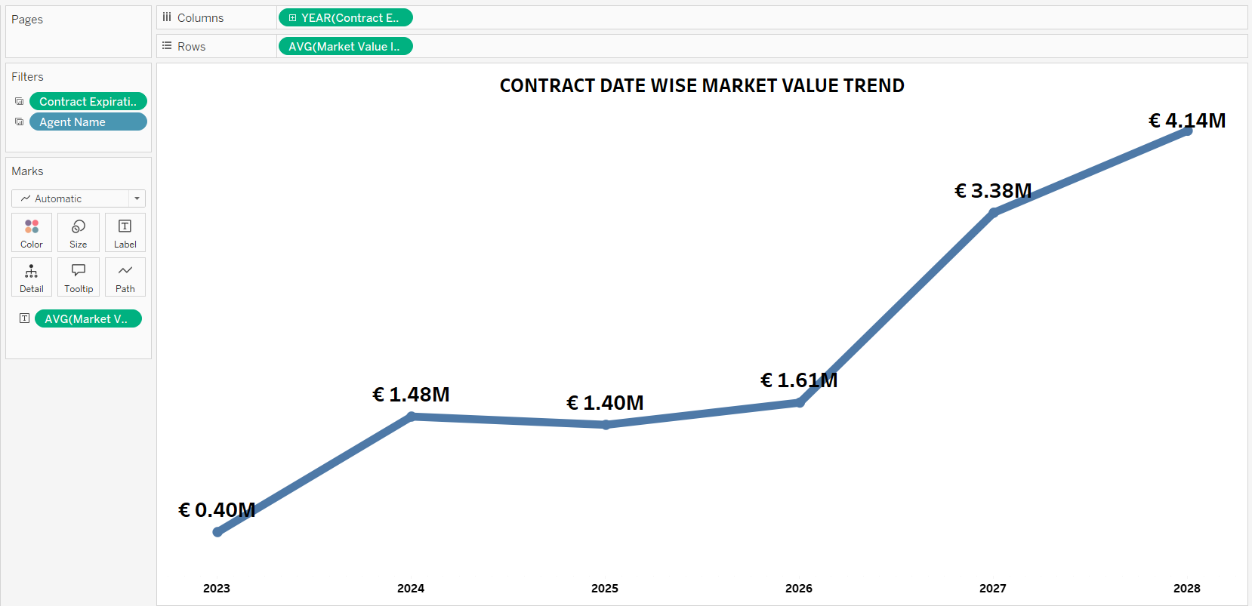
        2. INTERPRETATIONS:
           1. MARKET VALUE OF PLAYERS HAVING CONTRACT EXPIRATIONS DATES BEYOND 2026 HAVE AN EXPONENTIALLY HIGHER MARKET VALUE OF APPROXIMATELY € 4.14M EUROS
           2. MARKET VALUES OF PLAYERS HAVING CONTRACT EXPIRATION DATES UPTO 2026 ARE APPROXIMATELY € 1.61M EUROS
     2. Which players are nearing the end of their contracts and might need renewal?
        1. Using Tableau Gant Chart to represent the expiration dates for players and line chart of count of players expiring quarter wise  
           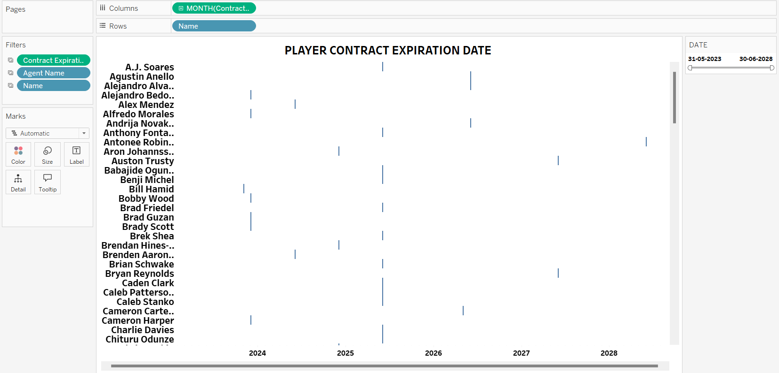  
           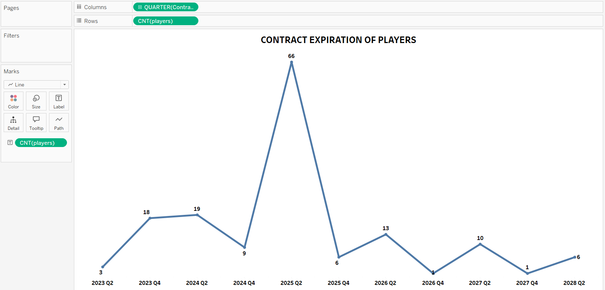
        2. INTERPRETATIONS:
           1. JUNE 2026 HAS 66 MOST NUMBER OF PLAYERS EXPIRING THEIR CONTRACT DATES
           2. THIS IS POTENTIAL INVESTMENT OPPORTUNITY FOR INVESTORS TO INVEST IN THESE PLAYERS
     3. What is the agent representation of the players?
        1. Using Tableau Highlight Chart to represent agents and the respective players having the current Market Value  
           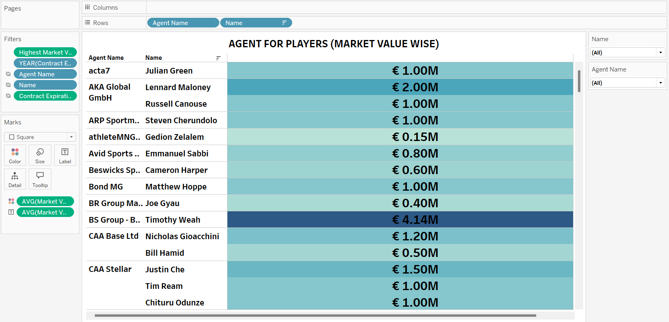
        2. INTERPRETATIONS:
           1. WASSERMAN AGENT HAS MOST NUMBER OF PLAYERS IN HIS CONTRACT (64 PLAYERS)

1. Exporting Files for PowerPoint Presentation
   1. Using Try – Except Block to export the required data into excel files for presentation
   2. Note – All excel sheets haven’t been used so haven’t attached the image related because as per the presentation it can change
2. INTERPRETATIONS AT A GLANCE:

**Summary of Interpretations for Each Business Question**

**1. Performance Analysis**

* **Player Contributions**:
  + *Christian Pulisic*: 4 average goals per season, balanced in both goals and assists, with few yellow cards.
  + *Aron Johannsson*: Dominates with 57 goals and 15 assists but has a stronger inclination toward goal-scoring rather than assisting.
  + *John Brooks*: Needs improvement with 38 yellow cards over several seasons, highlighting issues with aggression.
* **Key Players' Impact**:
  + Aron Johannsson contributed 142 goals, leading to 22 team wins, while Christian Pulisic contributed 57 goals, leading to 13 team wins.
* **Yellow/Red Cards**:
  + John Brooks (38 yellow cards) and Timothy Chandler (37 yellow, 1 red card) top the chart for fouls and cards, requiring disciplinary improvement.

**2. Player Profile & Market Trends**

* **Market Value vs. Age**:
  + Players over 30 experience a steep market value drop. Defenders lose around €100K annually (r = -0.51), midfielders lose €97K (r = -0.38), and attackers lose €77K (r = -0.32).
* **Height Correlation**:
  + Negligible correlation between height and market value (r = -0.03), indicating little to no effect on a player's worth.
* **Investment Opportunities**:
  + *Christian Pulisic* (€4.13M), *Luca de la Torre* (potential assist contributor with low average playtime), and *Josh Sargent* are flagged as high potential investment targets.

**3. Team Comparison**

* **Home vs. Away Performance**:
  + *Barcelona* excels at home, winning an average of 3 goals without conceding any. Teams like *Strasbourg* perform better away, averaging 4 goals with only 1 goal conceded.
* **Win/Loss Ratio**:
  + Teams like *Bayern Munich* have a 23:1 win/loss ratio in domestic leagues. In international cups, *Tottenham* stands out with a 9:1 win/loss ratio.
* **Manager Effectiveness**:
  + *John van den Brom* holds the best win-loss record (36 wins, 11 losses), while *Thomas Tuchel* boasts a remarkable 9:1 win-loss ratio.

**4. Attendance & Stadium Analysis**

* **Stadium Impact**:
  + Stadiums like *Signal Iduna Park* and *Goodison Park* are associated with over 60% wins, while *Villa Park* sees more than 50% losses.
* **Attendance Trends**:
  + *Weekends* attract about 73% stadium attendance, with over 40,000 attendees for high-profile matches.
* **Fan Engagement**:
  + *Borussia Dortmund* and *Manchester United* bring in the most fans, often exceeding 75,000 attendees.

**5. Referee Analysis**

* **Card Distribution**:
  + Referees like *Felix Zwayer* and *Guido Winkmann* issued the most yellow and red cards, signaling strict officiating.
* **Goal Influence**:
  + Referees such as *Christopher Jaeger* and *Alon Yefet* oversee high-scoring matches, with an average of 6 goals per game.

**6. Substitution Analysis**

* **Top Performers**:
  + Players like *Christian Pulisic* and *Josh Sargent* often come off the bench and contribute goals, with Pulisic scoring 4 goals in some games when substituted late.
* **Frequent Substitutes**:
  + *Right Back* and *Center Back* positions are the most frequently substituted, with over 250 substitutions, while *Right Midfield* is substituted the least.

**7. Event Analysis**

* **Goals and Match Outcome**:
  + Scoring before halftime increases the probability of winning by approximately 15%.
* **Late Game Impact**:
  + Goals scored in the last 15 minutes do not significantly alter match outcomes, according to statistical tests.

**8. Competition Analysis**

* **Team Dominance**:
  + *Borussia Verein* leads in both total goals and wins (932 goals, 74 wins) across all competitions.
* **High-Scoring Competitions**:
  + Domestic leagues consistently show the highest goal-scoring rates, with *Center Forwards* contributing 141 goals across all seasons.

**9. Player Attributes & Demographics**

* **Height & Performance**:
  + Players in the 160–170 cm height group score more goals (0.13) and assists (0.10) than other height groups.
* **Age Distribution**:
  + Players aged 30–35 score the most goals (0.12 per game), while younger players (20–25) provide the most assists (0.10 per game).

**10. Contract Management**

* **Upcoming Expirations**:
  + 66 players have contracts expiring in June 2026, representing a prime investment opportunity.
* **Agent Influence**:
  + The *Wasserman Group* represents the most players, with 64 under contract.

**Aggregated Summary of All Focus Areas**

1. **Player Performance**:
   * Christian Pulisic and Aron Johannsson are standout players, with balanced contributions of goals and assists, though Johannsson is more goal-focused (142 goals).
   * Improvements in aggression and discipline are necessary for players like John Brooks and Timothy Chandler, who lead in yellow cards.
2. **Market Trends**:
   * Players’ market value decreases significantly with age, especially defenders losing up to €100K annually.
   * Height has almost no impact on market value (r = -0.03).
3. **Team & Manager Comparison**:
   * *Barcelona* excels at home with a 3-goal average win, while *Bayern Munich* leads with a 23:1 win-loss ratio in domestic competitions.
   * Managers like *Thomas Tuchel* and *John van den Brom* have stellar win-loss records, highlighting their tactical superiority.
4. **Attendance Patterns**:
   * Stadiums like *Signal Iduna Park* are associated with high win rates, while attendance peaks during weekends, attracting up to 73% of total capacity.
   * Teams like *Borussia Dortmund* consistently bring in over 80,000 fans, showing strong fan engagement.
5. **Referee & Event Influence**:
   * Strict referees like *Felix Zwayer* issue the most cards, while goals scored late in the game have minimal impact on match results.
6. **Substitutions**:
   * Key players, like *Christian Pulisic*, often score after being substituted, showing the strategic use of substitutions in later game stages.
7. **Player Contracts**:
   * June 2026 is a critical date with 66 player contracts expiring, offering a potential for strategic investment.
   * *Wasserman Group* dominates agent representation with 64 players

**Comprehensive Analysis of Machine Learning Models and Hypothesis Testing**

## **Comprehensive Analysis of Machine Learning Models and Hypothesis Testing**

**1. Logistic Regression for Predicting Yellow Cards**

* **Objective**: Predict if a player will receive a yellow card based on performance metrics like goals, assists, and minutes played.
* **Performance Metrics**:
  + **Precision**: 87% accuracy in predicting players who **will not** receive yellow cards.
  + **Limitations**: The model performs poorly in predicting players **who do** receive yellow cards.
* **Key Insights**: The model shows strong precision for predicting no-yellow-card outcomes but lacks reliability for positive predictions. This suggests the need for additional features which is lacked by the data set.

**2. K-Means Clustering for Player Grouping by Market Value and Attributes**

* **Objective**: Cluster players based on their market value, height, country, and age to identify potential investment opportunities.
* **Optimal K**: The Elbow method determined the optimal number of clusters as **12**.
* **Performance Metrics**:
  + **WCSS (Within Cluster Sum of Squares)**: At K=12, the rate of change in WCSS was 60%, indicating the most significant reduction in intra-cluster variance.
  + **Clustering Outcome**: Players were effectively grouped into 12 distinct clusters based on their attributes.
* **Key Insights**: The clustering model reveals distinct groups of players, helping teams and investors identify under-valued talent or high-potential players in smaller clusters. This is a valuable tool for making strategic investment decisions in the transfer market.

**3. K-Nearest Neighbors (KNN) for Stadium Attendance Classification**

* **Objective**: Classify stadiums based on historical attendance patterns.
* **Performance Metrics**:
  + **Overall Accuracy**: 27%, indicating weak overall performance.
  + **F1-Score**: The model achieved an F1-score of over 70% for specific stadiums, such as *Signal Iduna Park* and *Veltins-Arena*.
* **Key Insights**: While the model’s general accuracy is low, it performs well for certain stadiums, making it useful for predicting high-attendance events at specific venues. Further enhancements could include adding features like match importance, ticket prices, and local fanbase size to improve overall model performance.

**4. Linear Regression for Market Value Prediction**

* **Objective**: Predict player market value based on goals, assists, and minutes played.
* **Performance Metrics**:
  + **Correlation Coefficients**:
    - *Goals and Market Value*: r ≈ 0 (near-zero correlation).
    - *Assists and Market Value*: r ≈ 0 (near-zero correlation).
    - *Minutes Played and Market Value*: r ≈ 0 (low correlation).
  + **Training Score**: The model produced a low training score of **0.0236**, indicating a poor fit and weak predictive power.
* **Key Insights**: The linear regression model failed to predict market value effectively, with weak correlations between performance metrics (goals, assists, and minutes played) and market value. This suggests that market value is influenced by other factors, such as branding, fan following, contract length, or endorsements, which were not included in the model. Future improvements could include adding these variables to enhance prediction accuracy.

**5. Hypothesis Testing for Impact of Goals Scored in the Last 15 Minutes**

* **Objective**: Test whether goals scored in the last 15 minutes of a match significantly impact the final result (win/loss).
* **Method**: Z-Test for hypothesis testing, assuming known population standard deviation and sample size > 30.
* **Results**:
  + At a 95% confidence level, the Z-test results showed that goals scored in the last 15 minutes **do not significantly influence** the final match outcome.
* **Key Insights**: The statistical test indicates that late-game goals have minimal impact on determining the match result, suggesting that teams should focus on consistent performance throughout the game rather than relying on late-game strategies. This insight can guide tactical decisions to emphasize strong play earlier in the game.